    Joint Video Experts Team (JVET)  of ITU-T SG 16 WP 3 and ISO/IEC JTC 1/SC 29  29th Meeting, by teleconference, 11–20 January 2023 | Document: JVET-AC0316-v1

Title: | [Informative] ISO 22028-5 impact on CICP
Status: | Input document to JVET
Purpose: | Informative
Author(s) or  Contact(s): | Nicolas Bonnier,  Davide Concion,  Ying Li,  Dimitri Podborski,  Jackson Roland,  Michel Rynderman,  Alexis Tourapis | Tel:  Email: | atourapis@apple.com dpodborski@apple.com
Source: | Apple Inc.
_____________________________

Abstract
ISO TC42 is currently developing specification ISO 22028-5 [1], which defines a set of colour image encodings for use in storage, transmission, and display of HDR and WCG digital still images. The purpose of this contribution is to inform JVET group on the impact of this work to the CICP specification [2].

Discussion
ISO 22028-5 is mostly built on known technologies such as the use of ITU-R Rec. BT.2100, and the Mastering Display Colour Volume (MDCV), Content Colour Volume (CCV) and Colour Light Level (CLL) metadata. However, it also defines new colour image encodings. In particular, it extends HLG to support reference displays with brightness characteristics beyond what is referenced in ITU-R Rec. BT.2100, i.e. with a peak brightness of 1 000 cd/m². This is referred to as the display-viewing colorimetry HLG (Figure 1). Such display characteristics can be provided to the decoder using additional metadata and in particular the MDCV.
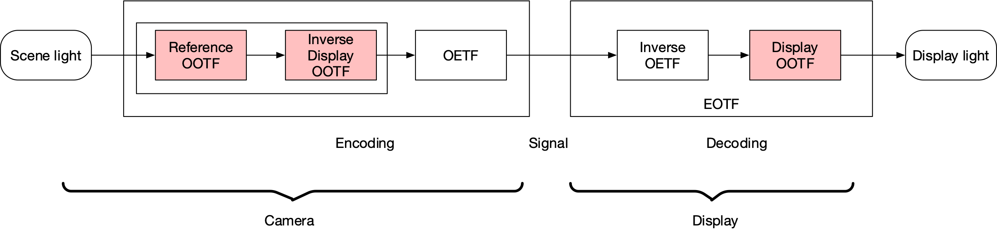
Figure 1: Display-viewing colorimetry HLG
On the other hand, it also defines a new use case of HLG referred to as the Scene-referred colorimetry HLG (Figure 2). For this transfer characteristics no display OOTF is applied and the HLG OETF is applied directly on the captured signal which has only scene light colorimetry applied to it. Images in this format could be used in some other applications of photography, where it is desirable that the decoded signal represents the colorimetry of the scene [1]. A scene-referred colorimetry PQ transfer characteristics is also defined in the same document.
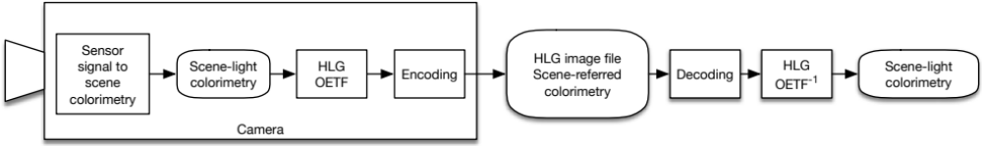
Figure 2: Scene-referred colorimetry HLG [1]
For decoding systems to recognize these new uses of the HLG and PQ transfer characteristics, we believe that new code points need to be introduced in the CICP and all relevant video specifications. Such new code points, when encountered, will indicate to the decoder or the display the type of the transfer characteristics e.g. whether it is the display-viewing colorimetry HLG with the nominal or an explicitly defined reference display, or the scene-referred colorimetry HLG. In the case of the display-viewing colorimetry HLG with an explicitly defined reference display additional metadata, i.e. MDCV metadata will have to be used when decoding and displaying the signal.
Given such usage we expect two additional code points to be defined for HLG and a clarification to be made for the existing HLG code point that this should be used only for content created with a reference display of 1 000 cd/m² peak brightness.
A new code point for scene-referred colorimetry PQ may also need to be defined.

Conclusion
Our intent is to inform JVET of this work and to make it aware that the CICP specification will need to be updated upon completion of the ISO 22028-5 project.

References
- ISO TC 42/WG 23, TS 22028-5 "Photography and graphic technology — Extended colour encodings for digital image storage, manipulation and interchange — Part 5: High dynamic range and wide colour gamut image encoding for still images (HDR/WCG)"
- ISO/IEC 23091-2: Information technology — Coding-independent code points — Part 2: Video

