    Joint Video Experts Team (JVET)  of ITU-T SG 16 WP 3 and ISO/IEC JTC 1/SC 29  29th Meeting, by teleconference, 11–20 January 2023 | Document: JVET-AC0267-v1

Title: | Training Methods in Visual Assessment: Potential Improvements for Expert Viewing Tests
Status: | Input document
Purpose: | Information
Author(s) or  Contact(s): | Mathias Wien  (RWTH Aachen University, DE)  Vittorio Baroncini  (VABtech, GB) | Tel:  Email: | wien@lfb.rwth-aachen.de  baroncini@gmx.com
Source: | SC 29/AG 5
_____________________________

Abstract
This document reports results of a subjective assessment which was carried out in addition to the tests reported in JVET-AB2029 at the Mainz meeting site with a small group of experts and a modified training procedure. The goal of this additional subjective test is to investigate the effectiveness of the modified training procedure and the feasibility of a smaller group of viewers for the expert viewing scenario.
The scatter plots seem to indicate a consistent behavior of the MOS scores resulting from the two tests. This applies to the resulting MOS values as well as to the corresponding confidence intervals. These results suggest that a comparable confidence may have been reached with half the number of expert viewers. Considering the effort of conducting expert viewing tests, this result is taken as an encouraging indication to further study and potentially refine the modified training method.
The MOS-rate plots resulting from the reported tests reveal a benefit of the VVenC bitstreams compared to the VTM bitstreams for about half of the test sequence. For the other half, the results do not indicate a clear trend towards the one or the other encoder. It is noted that the plots for the Campfire, CatRobot1, and DaylightRoad2 sequences show saturation effects for the highest rate point each. These effects were not observed in the results reported in JVET-AB2029.

Introduction
In JVET-AB2029 [1], the results of subjective assessments comparing the compression performance of the ECM-6 to the VTM-11 with ECM-comparable settings were reported. For a test set including UHD and HD video test sequences encoded with test configurations UHD-RA, HD-RA, and HD-LD, using the random-access (RA) and low-delay (LD) configuration files available with the corresponding VTM and ECM software. Two tests were conducted on the provided test set: An expert viewing test at the Mainz meeting site and a laboratory test with naïve test subjects by VABTech in Rome. A total of 24 viewers participated in the tests at both sites. This document reports results of an additional subjective assessment which was carried out at the Mainz meeting site with a smaller group of experts and a modified training procedure. The goal of this additional subjective test is to investigate the effectiveness of the modified training procedure and the feasibility of a smaller group of viewers for the expert viewing scenario.
The test was performed re-using the VTM bitstreams for the UHD resolution of the above-mentioned comparison and corresponding VVC bitstreams encoded with VVenC [4]. The generation of these bitstreams was discussed and agreed in the AHG meetings preparing for the JVET-AB2029 comparison [2]. In this context, the AHG suggested a rate matching for VVenC using 2-pass encoding with rate control, hence enabling very close matching of the rate points.

Test setup

Logistics
At the meeting site in Mainz, two identical setups were employed. These included a PC with a Decklink video board for HDMI connection and SSD drives capable of stable playout of the raw YUV data at the required frame rate.
Test Site | On-site
Display, size, connection  (resolution setting) | 2× LG 65” E9, HDMI (3840×2160)
Viewing distance | 3 viewers at 1.5H
Viewing angle | ±75°, 90° (at screen center)
Total number of viewers | 12 (3 female, 9 male)
Participating experts confirmed visual acuity and normal colour vision.

Test sequences and quantizer settings
For the evaluation, the UHD sequences from the JVET-AB2029 test set were employed.
Class | Sequence name | fps | Frames | md5 hash
UHD RA | Campfire | 30 | 300 | 63d3d9f9e4e8b5c344e89840e84e6428
UHD RA | CatRobot1 | 60 | 600 | 03a89792693fd9ecfd72ef2590025e97
UHD RA | DaylightRoad2 | 60 | 600 | bf1d22643afb41b1521749d2749fb5f0
UHD RA | DrivingPOV3 | 60 | 600 | e81b65724c4235128b2749ccb3b0fb4a
UHD RA | Marathon2 | 30 | 300 | c065dfb87be3b2e2ab0ce35094fd4eb4
UHD RA | MountainBay2 | 30 | 300 | f27b6b70244fb083baac546958fcf696
UHD RA | TallBuildings2 | 30 | 300 | 9a0a3f261d004fa86754751c82fb8b47
The VVC bitstreams encoded with VVenC were encoded using software version v1.6.1 with the “slow” preset, two-pass rate control, and the quantization parameter adaptation (QPA) algorithm activated. The bitrates and the resulting deviation are reported in the table below.
Sequence | VTM QP | Rate VTM | Rate VVenC | Bitrate deviation from VTM
Campfire | 43 | 1396.63 | 1385.29 | 0.81%
Campfire | 39 | 2575.79 | 2555.91 | 0.77%
Campfire | 35 | 4600.17 | 4549.53 | 1.10%
Campfire | 30 | 7694.10 | 7628.63 | 0.85%
CatRobot1 | 43 | 987.37 | 978.23 | 0.93%
CatRobot1 | 39 | 1604.44 | 1579.78 | 1.54%
CatRobot1 | 35 | 2618.21 | 2593.5 | 0.94%
CatRobot1 | 30 | 4426.94 | 4404.6 | 0.50%
DaylightRoad2 | 45 | 639.55 | 640.24 | -0.11%
DaylightRoad2 | 41 | 1079.68 | 1082.48 | -0.26%
DaylightRoad2 | 37 | 1823.12 | 1818.04 | 0.28%
DaylightRoad2 | 30 | 4325.31 | 4263.92 | 1.42%
DrivingPOV3 | 47 | 559.94 | 557.91 | 0.36%
DrivingPOV3 | 43 | 1017.72 | 998.62 | 1.88%
DrivingPOV3 | 39 | 1776.79 | 1784.4 | -0.43%
DrivingPOV3 | 33 | 3832.26 | 3822.1 | 0.27%
Marathon2 | 44 | 1193.16 | 1191.25 | 0.16%
Marathon2 | 40 | 2114.33 | 2110.49 | 0.18%
Marathon2 | 36 | 3652.54 | 3655.06 | -0.07%
Marathon2 | 30 | 8601.63 | 8577.77 | 0.28%
MountainBay2 | 44 | 298.38 | 296.73 | 0.55%
MountainBay2 | 40 | 576.79 | 574.38 | 0.42%
MountainBay2 | 34 | 1606.16 | 1603.82 | 0.15%
MountainBay2 | 30 | 3246.85 | 3229.84 | 0.52%
TallBuildings2 | 45 | 538.79 | 534.67 | 0.77%
TallBuildings2 | 42 | 828.38 | 828.65 | -0.03%
TallBuildings2 | 37 | 1633.04 | 1612.89 | 1.23%
TallBuildings2 | 33 | 2766.33 | 2685.42 | 2.92%
All sequences under evaluation are of 10sec length. The original files as well as the bitstreams for the tested rate points are available on the JVET ftp site under /ahg/ECM-test/test/.

Test method and test design
The Degradation Category Rating (DCR) method was applied for the subjective evaluation [5]. The test sequences were evaluated using the 11-grade scale as specified in Rec. ITU-R BT.500-14 [6], shown in Figure 1 below.
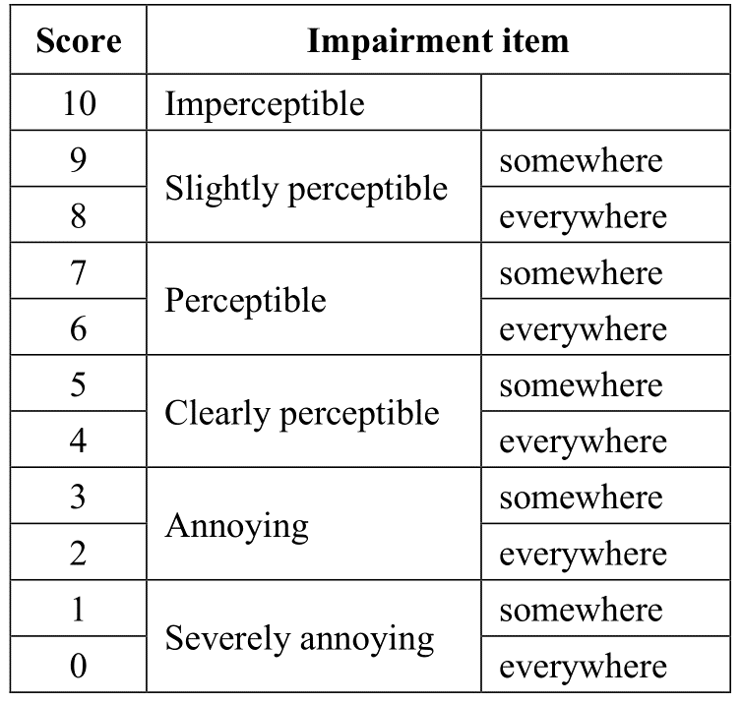
Figure 1: Meaning of the 11 grades numerical scale as specified in Rec. ITU-R BT.500-14 Table 2-4
Each basic test cell (BTC) is structured as followed:
“A” (1sec) – [reference] (10sec) – “B” (1sec) – [PVS] (10sec) – “Vote <N>” (5sec)
[reference] denotes the uncompressed video sequence
[PVS] denotes the processed video sequence under evaluation.

Test sessions
Three test sessions were designed. All test sessions included a stabilization phase (three BTCs) as suggested in ITU-R BT.500-14. The session duration was chosen to be no longer than 13 minutes with 24 votes in each session. The test sessions included trapping BTCs where the original uncompressed sequence was shown for evaluation.
The test sessions were presented with a viewing distance of 1.5H of the UHD display for the center seat.

Modified Training method

Context
When a visual assessment of video is required, the assessment procedure is a key aspect in the achievement of reliable and usable results. An important part of the procedure is the training of the humans participating to the experiment. The traditional training strategies were based of the reading of an explanatory text followed by a short training test session; the training sessions has not to included test video clips used in the actual test; questions were admitted at the end of the training sessions. This approach showed strong limitations; the standard deviation of the data produced by the participants to the experiment was wide and reduced the ability of ranking of the test conditions.
The new training strategies allowed the use of video used for the actual test, and a deep and accurate description of the possible impairments when the training session was run. The content of the training session had to include as many as possible visual quality cases, able to cover the whole quality range foreseen in the experiment.
This approach produces a significant improvement of the results by lowering the standard deviation (and consequently the confidence interval, CI), and thereby providing a higher discrimination capability for the visual assessment.
When expert viewing (i.e. a visual assessment where naïve viewers are replaced by experts in the video coding area) was introduced, the training phase was initially considered to be of lower importance. However, the results tend to show very high standard deviation values. This observation suggests to reiterate on the training of the experts, mainly devoted to providing an accurate description of the organization and structure of the experiment (what was shown and when and how to express the scores).
Nevertheless, the values of the standard deviation in expert viewing experiments remained higher, mainly when compared with those obtained when running a test with naïve viewers on the same contents.
These observations motivate the development of a new design of the training procedures. It is noted that this matter has not been resolved so far and it is matter of further study. One possible solution to the above-mentioned problem is described below.

Description
The test procedure described here is based on the DCR (Degradation Category Rating) test methods.
A set of “ground truth” MOS values is prepared for each test case to be used in the training sessions; the “ground truth” MOS values are prepared by the test administrators. The set of “ground truth” MOS try to figure out an “ideal” visual assessment, that provides the better MOS for each case.
The training session is edited by modifying the BTC of the DCR method: at the end of the voting period, the “ground truth” MOS value is disclosed. The presented value is commented by the test administrator explaining that the shown score is the one “suggested” for a correct evaluation of that PVS.
For the reported tests, a training session with 9 BTCs was designed with example VTM and ECM bitstreams covering all test sequences occurring in the viewing sessions, and the corresponding “ground truth” MOS values taken from the expert viewing sessions of the JVET-AB2029 tests.

Results and analysis
In the following, the results achieved from the tests reported in JVET-AB2029 are referred to was Test 1. The results of the tests with the modified training method are referred to as Test 2.

Data processing
The scores were first screened for the trapping sequences. The viewers consistently scored the originals with a MOS score of 9 or 10, with only to votes indicating a score of 8. The Pearson correlation coefficient of the viewers were in the range of 0.89 to 0.97 with an average value of 0.94. Based on these results, no further outlier processing was applied.

Scatter plots comparing Test 1 and Test 2 for the VTM results
In order to study the relation of the MOS values resulting from Test 1 and Test 2, scatter plots are provided where the Test 2 MOS values are arranged along the abscissa and the Test 1 MOS values are arranged along the ordinate. The MOS results for the VTM bitstreams are reported since only these have been evaluated in both, Test 1 and Test 2. The linear trendline for the four points is plotted as a blue dashed line. Further, the confidence interval on the corresponding axis is indicated for each data point. The line of slope 1 is added to mark the location of a theoretically ideal match between the two tests.
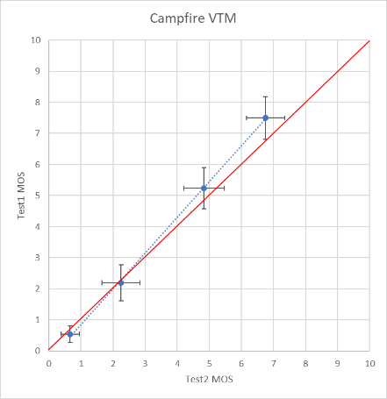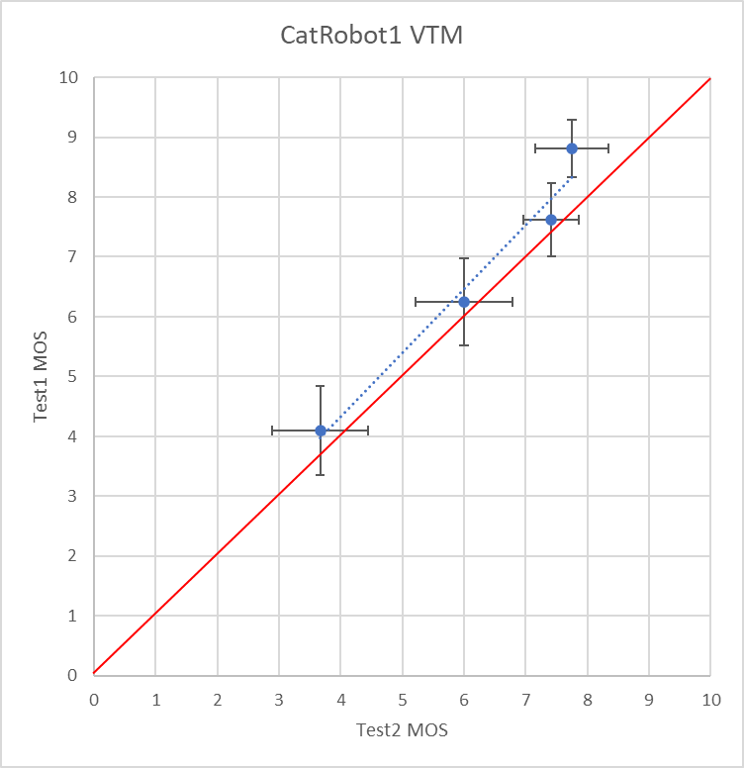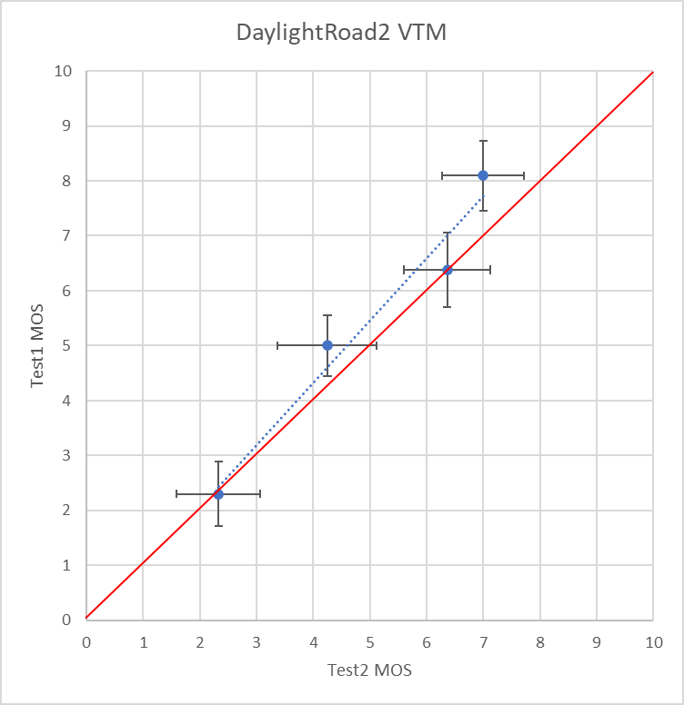
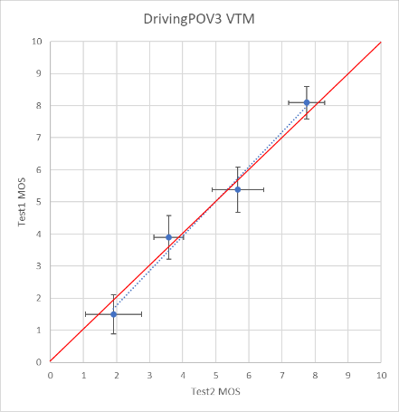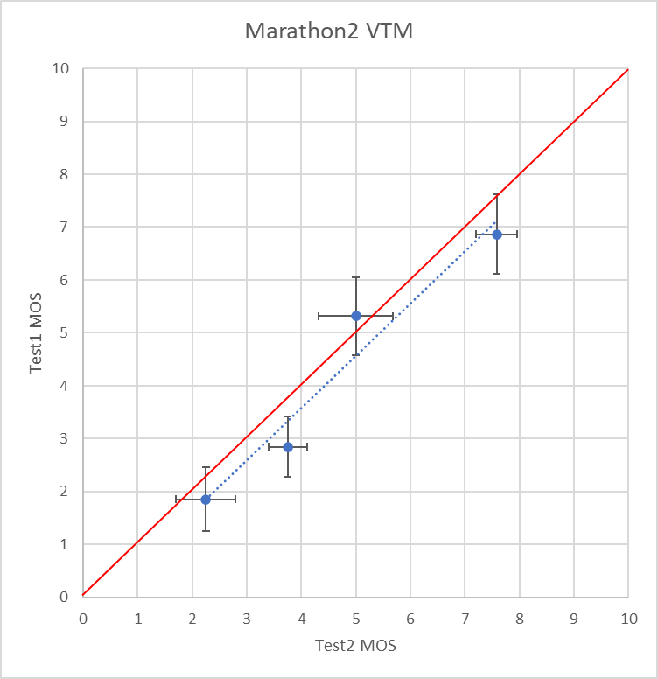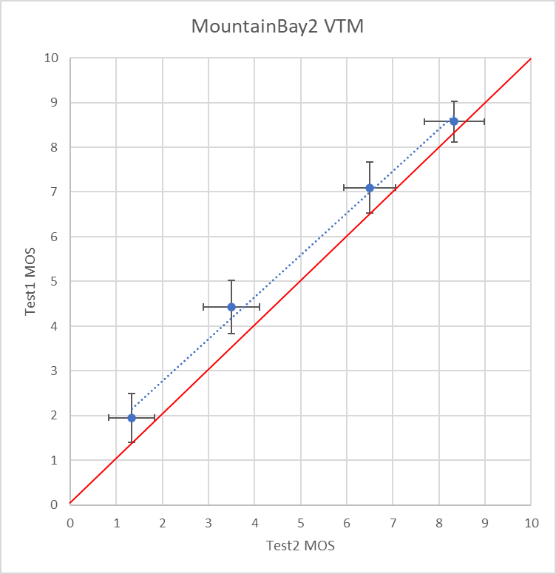
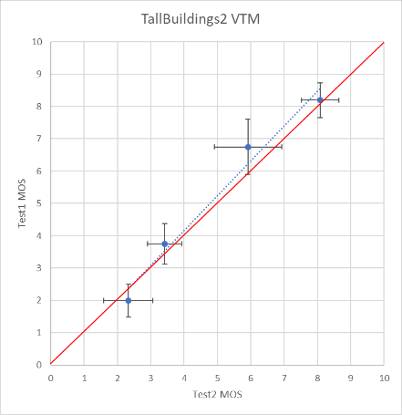

MOS-rate plots comparing VTM and VVenC
For comparison of the performance of the VTM and VVenC encoders, the MOS values of Test 2 are plotted over the corresponding bitrate. The ±95% confidence intervals for the MOS values are indicated.
The MOS results as well as the bitrates values are provided in the accompanying spreadsheet.
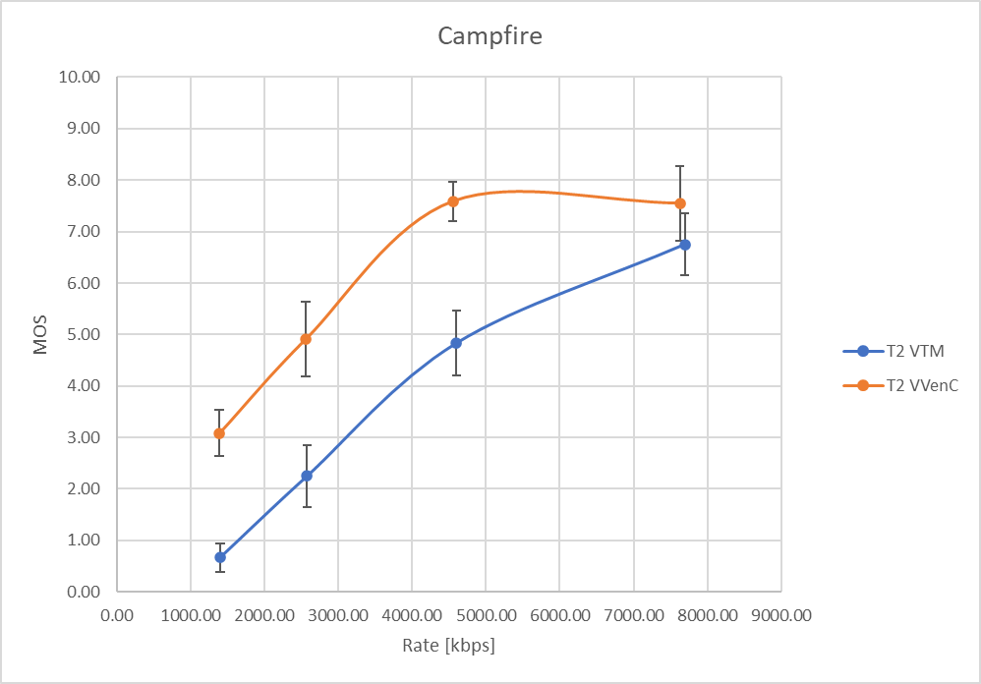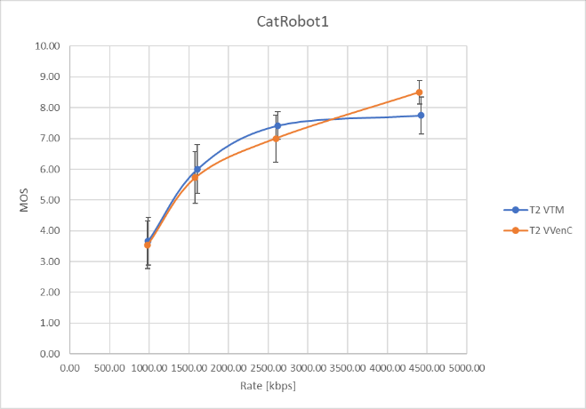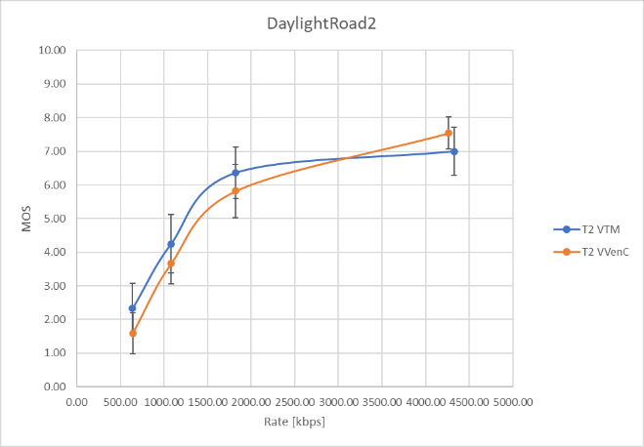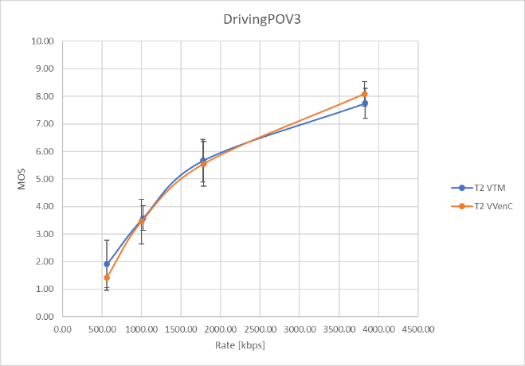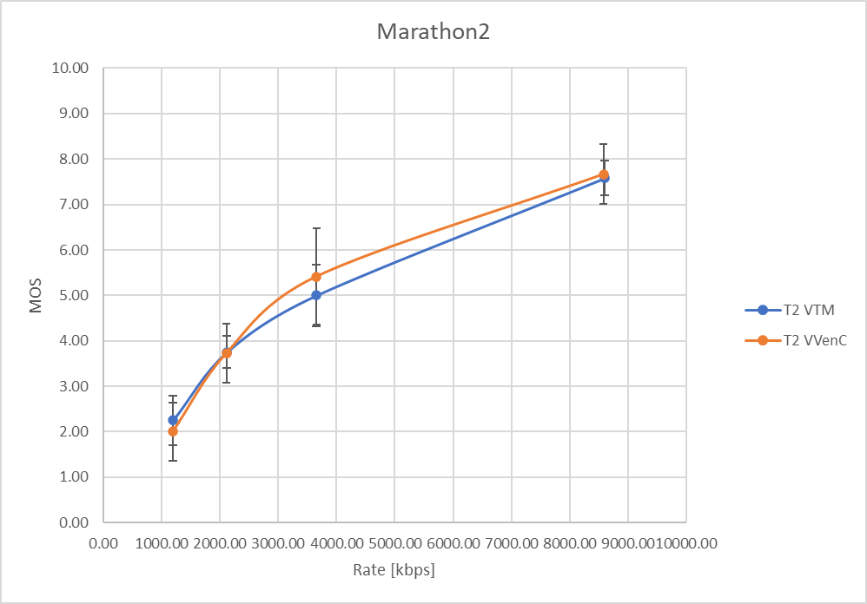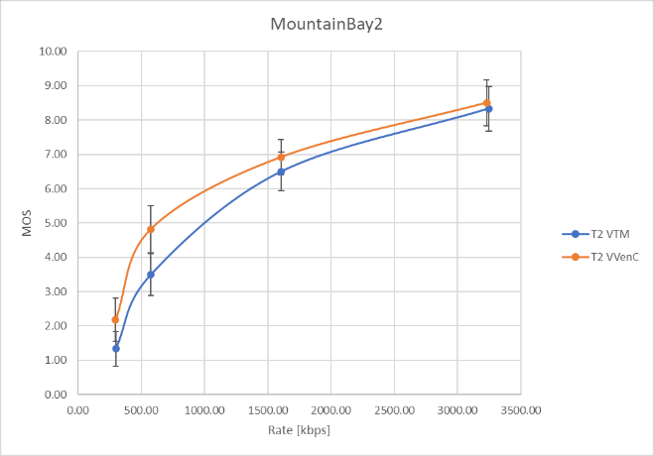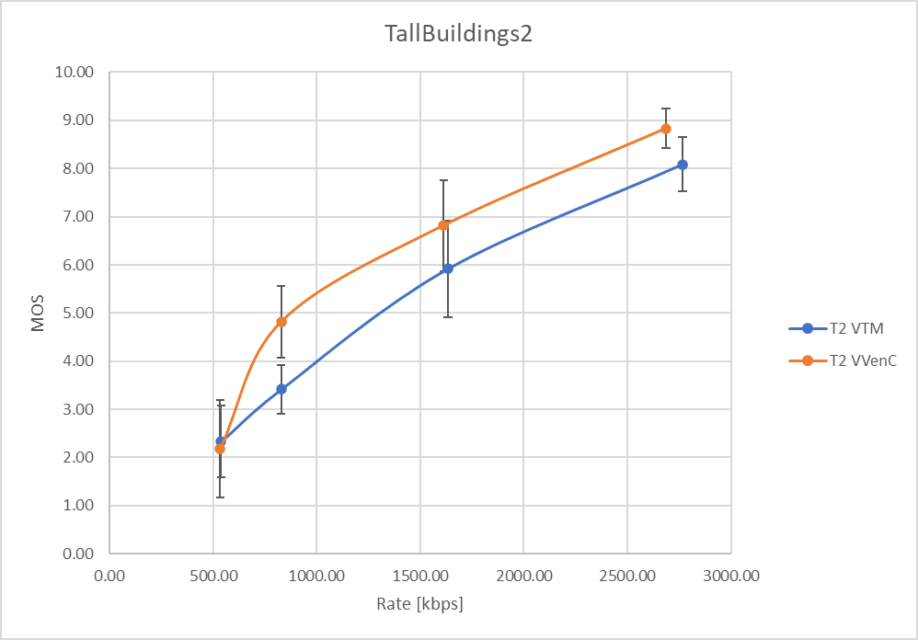

Discussion and conclusions
The scatter plots reveal a quite consistent behavior of the MOS scores resulting from Test 1 and Test 2. For all test sequences, the trendline of the data points is close to the main diagonal. It is further noted that out a total of 28 data points, 19 points have an overlap of the CIs for both axes with the main diagonal. In three cases, only one of the CIs overlaps, and in six cases, the CIs do not overlap with the main diagonal. From this, it is concluded that the results can be considered consistent for both tests. Comparing the confidence intervals by size, it is noted that in many cases, a very similar CI is observed. Computing the ratio between the CIs of data points from Test 1 and Test 2, a ratio range of 0.5 to 1.59 is observed, with an average of 1.04 and a standard deviation of 0.25. These results suggest that a comparable confidence has been reached with half the number of expert viewers. Considering the effort of conducting expert viewing tests, this result is taken as an encouraging indication to further study and potentially refine the modified training method.
The MOS-rate plots reveal a significant benefit of the VVenC bitstreams compared to the VTM bitstreams for the Campfire sequence. For the test sequences MountainBay2 and TallBuildings2, a -sometimes clear- benefit is observed, with partially non-overlapping confidence intervals. The test sequences CatRobot1, DaylightRoad2, DrivingPOV3, and Marathon2 do not show a clear trend towards the one or the other encoder. Especially for DrivingPOV3, the results are observed to be quite similar. It is noted that the plots for the Campfire, CatRobot1, and DaylightRoad2 sequences show saturation effects for the highest rate point each. These effects were not observed in the Test 1 setting.

Patent rights declaration(s)
RWTH Aachen University or VABtech do not have any current or pending patent rights relating to the technology described in this contribution.

References
- M. Wien, J.-R. Ohm, V. Baroncini “Visual quality comparison of ECM/VTM encoding,” Doc. JVET-AB2029, Joint Video Experts Team (JVET) of ITU-T SG 16 WP 3 and ISO/IEC JTC 1/SC 29/WG 5, 28th meeting, Mainz, DE, Oct. 2022.
- M. Wien, “AHG4, 7, 12: Report on AHG meetings on ECM performance evaluation preparation,” Doc. JVET-AB0041, Joint Video Experts Team (JVET) of ITU-T SG 16 WP 3 and ISO/IEC JTC 1/SC 29/WG 5, 28th meeting, Mainz, DE, Oct. 2022.
- JVET, VTM software package, https://vcgit.hhi.fraunhofer.de/jvet/VVCSoftware_VTM/-/tree/VTM-11.0.
- VVenC software repository. https://github.com/fraunhoferhhi/vvenc
- Recommendation ITU-T P.910 (2008), Subjective video quality assessment methods for multimedia applications.
- Recommendation ITU-R BT.500-14 (2019), Methodologies for the subjective assessment of the quality of television images.

