    Joint Video Experts Team (JVET)  of ITU-T SG 16 WP 3 and ISO/IEC JTC 1/SC 29  29th Meeting, by teleconference, 11–20 January 2023 | Document: JVET-AC0239-v2

Title: | Non-EE2: Prediction of MVD magnitude suffix bins
Status: | Input document to JVET
Purpose: | Proposal
Author(s) or  Contact(s): | A. Filippov,  V. Rufitskiy,  K. Suverov | Tel:  Email: | afilippov@ofinno.com  vrufitskiy@ofinno.com
Source: | Ofinno LLC
_____________________________

Abstract
This contribution presents a technique for predicting MVD magnitude suffix bins. In fact, we proposed a technique that is an extension of MVD sign prediction, which is a part of ECM-7.0. In this design, not just signs but also magnitude suffix bins of exponential Golomb code are predicted by estimating template matching cost of candidate blocks to take advantage of regular CABAC mode rather than its by-pass mode at the entropy coding stage. On top of ECM-7.0, the following BD-rate gain results are reportedly obtained for Test 1, where a maximum of 6 bins (including sign bins) are predicted for blocks with width and height larger than 4 (affine motion compensation is enabled for these block sizes), and maximum of 2 bins are predicted for blocks that have either width or height equal to 4 (affine motion compensation is disabled for these block sizes) {-0.05%, -0.00%, -0.01%} for RA configuration and {-0.08%, 0.02%, -0.03%} for LDB configuration. On top of ECM-7.0, the following BD-rate gain results are reportedly obtained for Test 2, where a maximum of 6 bins (including sign bins) are predicted for blocks with width and height larger than 4 (affine motion compensation is enabled for these block sizes), and maximum of 4 bins are predicted for blocks that have either width or height equal to 4 (affine motion compensation is disabled for these block sizes) {-0.08%, -0.02%, -0.04%} for RA configuration and {-0.11%, -0.06%, -0.06%} for LDB configuration.

Introduction
In [1] and [2], MVD sign prediction adopted into the ECM software was proposed. This technique aims at improving the compression efficiency of MVD signs. Later, BVD sign and magnitude prediction method that takes advantage of regular CABAC mode for both BVD signs and BVD magnitude suffix bins was proposed in [3] and [4]. In this contribution, we propose a technique that extends MVD sign prediction by predicting MVD magnitude suffix bins as well.

Proposed methods
This proposal utilizes a similar approach to predict MVD suffix bins that was used in [1] and [2]. Most significant bins of MVD remainder suffixes are predicted using template matching and the correctness of prediction hypotheses are indicated by corresponding MVD suffix bins that are coded in the bitstream using regular CABAC mode. The proposed method is applied for MVDs of translational motion, including SMVD and MMVD, affine and affine MMVD modes. Candidates for template matching used to predict bin values are shown in Figure 1. The less significant bins of magnitude suffixes of horizontal and vertical MVD components may be coded in by-pass mode.

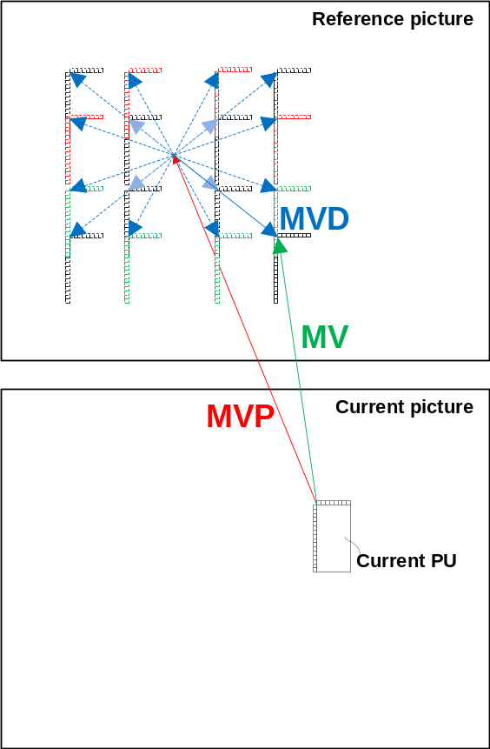
Figure 1: Prediction of MVD sign and magnitude suffix bins

Simulation results
The proposed method was implemented on top of ECM-7.0 and are tested under CTC for enhanced compression tool testing [5] for Random-Access, and Low-Delay B configurations.
In Test 1, maximum of 6 bins (including sign bins) are predicted for blocks with width and height larger than 4 (affine motion compensation is enabled for these block sizes), and maximum of 2 bins are predicted for blocks that have either width or height equal to 4 (affine motion compensation is disabled for these block sizes). The simulation results for Test 1 are shown in Table 1.

Table 1. The simulation results of the proposed method for Test 1
 | Random Access Main 10
 | Over ECM-7.0
 | Y | U | V | EncT | DecT
Class A1 | -0.07% | -0.03% | -0.06% | 101% | 100%
Class A2 | -0.02% | 0.07% | -0.12% | 101% | 100%
Class B | -0.09% | -0.02% | -0.09% | 100% | 100%
Class C | -0.03% | -0.01% | 0.21% | 101% | 100%
Class E
Overall | -0.05% | 0.00% | -0.01% | 101% | 100%
Class D | -0.04% | -0.18% | 0.84% | 100% | 100%
 | Low delay B Main10
 | Over ECM-7.0
 | Y | U | V | EncT | DecT
Class A1
Class A2
Class B | -0.09% | 0.03% | -0.06% | 100% | 100%
Class C | -0.06% | 0.02% | 0.00% | 101% | 101%
Class E | -0.10% | 0.01% | 0.00% | 102% | 99%
Overall | -0.08% | 0.02% | -0.03% | 101% | 100%
Class D | -0.01% | -0.03% | -0.01% | 101% | 101%

In Test 2, maximum of 6 bins (including sign bins) are predicted for blocks with width and height larger than 4 (affine motion compensation is enabled for these block sizes), and maximum of 4 bins are predicted for blocks that have either width or height equal to 4 (affine motion compensation is disabled for these block sizes). The simulation results for Test 2 are shown in Table 2.
Table 2. The simulation results of the proposed method for Test 2
 | Random Access Main 10
 | Over ECM-7.0
 | Y | U | V | EncT | DecT
Class A1 | -0.11% | -0.03% | -0.10% | 102% | 100%
Class A2 | -0.03% | 0.05% | -0.07% | 102% | 100%
Class B | -0.09% | -0.06% | -0.12% | 99% | 100%
Class C | -0.08% | -0.01% | 0.11% | 101% | 100%
Class E
Overall | -0.08% | -0.02% | -0.04% | 101% | 100%
Class D | -0.07% | -0.19% | 0.87% | 101% | 100%
 | Low delay B Main10
 | Over ECM-7.0
 | Y | U | V | EncT | DecT
Class A1
Class A2
Class B | -0.13% | -0.08% | -0.08% | 100% | 100%
Class C | -0.08% | -0.03% | -0.01% | 101% | 101%
Class E | -0.12% | -0.08% | -0.11% | 101% | 99%
Overall | -0.11% | -0.06% | -0.06% | 101% | 100%
Class D | -0.04% | -0.06% | -0.03% | 101% | 101%

Conclusion
In this contribution, we proposed a technique for predicting MVD magnitude suffix bins. We recommend studying the proposed technique in the next round of Exploration Experiment 2 (EE2).

References
- Y. Zhang, B. Ray, H. Huang, V. Seregin, and M. Karczewicz, “Non-EE2: On MVD sign prediction,” JVET-X0132, October 2021.
- M. Salehifar, Y. He, K. Zhang, N. Zhang, L. Zhang, Y. Zhang, B. Ray, H. Huang, V. Seregin, and M. Karczewicz, “EE2-3.9 and EE2-3.10: TM based reordering for MMVD and affine MMVD and MVD sign prediction”, JVET-Y0067, January 2022.
- A. Filippov and V. Rufitskiy, “Non-EE2: Block Vector Difference Prediction for IBC blocks,” JVET-AB0170, October 2022.
- A. Filippov and V. Rufitskiy, “EE2-3.3: Block Vector Difference Prediction for IBC blocks,” JVET-AC0104, January 2023.
- M. Karczewicz and Y. Ye, “Common Test Conditions and evaluation procedures for enhanced compression tool testing,” JVET-Y2017, Feb. 2022.

Patent rights declaration(s)
Ofinno LLC may have current or pending patent rights relating to the technology described in this contribution and, conditioned on reciprocity, is prepared to grant licenses under reasonable and non-discriminatory terms as necessary for implementation of the resulting ITU-T Recommendation | ISO/IEC International Standard (per box 2 of the ITU-T/ITU-R/ISO/IEC patent statement and licensing declaration form).

