    Joint Video Experts Team (JVET)  of ITU-T SG 16 WP 3 and ISO/IEC JTC 1/SC 29  29th Meeting, by teleconference, 11–20 January 2023 | Document: JVET-AC0205-v2

Title: | EE2-related: Modifications of MTS and LFNST for IntraTMP
Status: | Input document to JVET
Purpose: | Proposal
Author(s) or  Contact(s): | Ramin G. Youvalari  Done Bugdayci Sansli  Jani Lainema | Email: | ramin.ghaznavi-youvalari@nokia.com,  done.bugdayci_sansli@nokia.com,jani.lainema@nokia.com
Source: | Nokia
_____________________________

Abstract
In ECM-7.0, an IntraTMP coded block uses block size dependent implicit MTS kernels as primary transform and LFNST transform set 0 as the secondary transform. Intra TMP coded blocks are assigned planar mode as the intra prediction mode. In JVET- AB0115 (EE2-4.1), it is proposed to derive the intra prediction mode for IntraTMP block using DIMD method.
This contribution proposes to inherit the intra prediction mode of an IntraTMP block from its reference block or from the neighborhood of its reference block. The proposed method has a simpler approach for selecting the intra prediction mode and it is reported to provide slightly higher coding gain than the EE tests.
The impacts on coding efficiency and runtimes over ECM-7.0 are reportedly {for Y, U, V, EncT, DecT}:
Test A:
AI { -0.05%, -0.01%, -0.07%, 101%, 101%}, RA { -0.02%, -0.08%, -0.06%, 98%, 95%}
Test B (in addition to Test A, the derived intra prediction mode is used in MPM list of neighboring blocks):
AI { -0.06%, -0.03%, -0.01%, 101%, 101%}, RA { -0.xx%, -0.xx%, -0.xx%, 1xx%, 1xx%}

Studied approach

Introduction
In ECM-7.0 [1], for a IntraTMP coded block, the operation of transform is as follows:
Primary transform:
Default: {DCT2, DCT2}
If 4 <= width <= 16, trTypeHor is DST7
If 4 <= height <= 16, trTypeVer is DST7
Secondary transform:
LFNST transform set 0. If the current block is IntraTMP coded block, predModeIntra is mapped to planar mode.
In general, for an intra predicted block, the MTS transform set is determined based on the predModeIntra and the block size. There are total 80 MTS transform sets and each set has 6 candidates in case of Intra mode. LFNST transform set is also determined based on the predModeIntra. There is total 35 transform sets and 3 non-separable transform matrices.

Proposed Method
This contribution proposes to inherit the intra prediction mode of an intraTMP block, from the prediction units in the reference area that the block is copied. Then the intra prediction mode is used to determine the LFNST and MTS transform sets. 5 locations in the reference area are scanned sequentially and when an angular intra prediction is found then the scan is terminated, and that mode is used for the transform selection.
Figure below illustrates the locations for deriving the intra prediction mode.
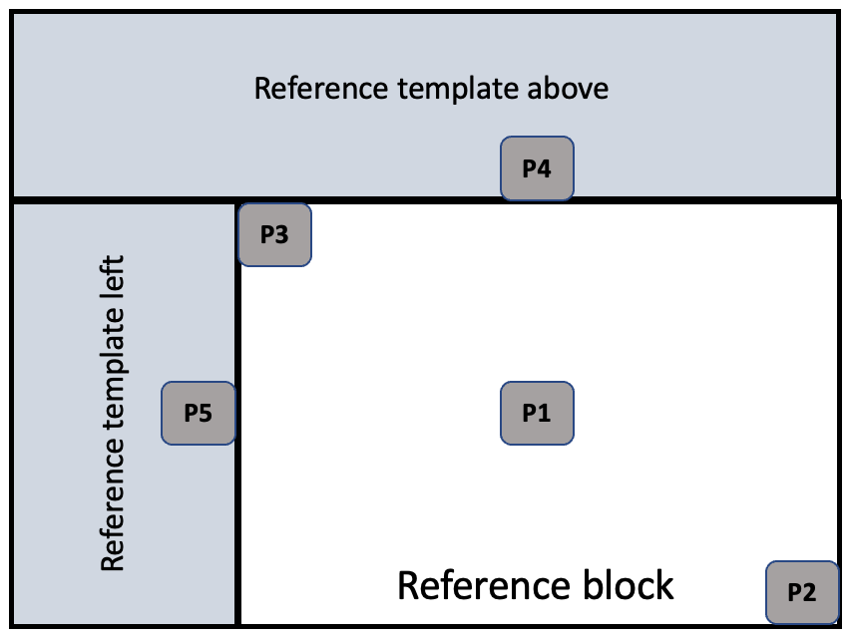
The scanning order is: P1, P2, P3, (P4, P5)
For the locations in the reference template area, if the height of the block is greater than the width, then the location P5 is checked prior to P4; otherwise, location P4 is checked before P5.

The first mode that is a normal intra prediction mode is selected and used, thus prediction units with below intra modes are skipped:
- MIP mode
- IntraTMP mode
- IBC mode
If no candidate found in these 5 locations, then planar mode is assigned for the intraTMP block and is used for transform selection.
Similar to EE2-4.1c, the inherited mode could be also stored and used in the MPM list of the neighbouring intra blocks.

Experimental results
Tables below summarize the coding efficiency and runtime impact of the proposed method in ECM 7.0 using the JVET common test conditions [2].
Results for test A:
The inherited mode is used for transform selection of intraTMP block.

 | All Intra Main10
 |  |  | Over ECM-7.0
 | Y | U | V | EncT | DecT
Class A1 | 0.00 % | -0.05 % | -0.06 % | 101 % | 102 %
Class A2 | -0.05 % | -0.05 % | 0.00 % | 101 % | 101 %
Class B | -0.06 % | 0.01 % | -0.08 % | 102 % | 101 %
Class C | -0.05 % | 0.00 % | -0.04 % | 101 % | 101 %
Class E | -0.10 % | 0.00 % | -0.15 % | 102 % | 102 %
Overall | -0.05 % | -0.01 % | -0.07 % | 101 % | 101 %
Class D | -0.02 % | -0.08 % | 0.07 % | 103 % | 99 %
Class F | -0.06 % | 0.09 % | -0.10 % | 102 % | 101 %
Class TGM | -0.02 % | 0.03 % | 0.02 % | 100 % | 100 %

 | Random Access Main10
 |  |  | Over ECM-7.0
 | Y | U | V | EncT | DecT
Class A1 | 0.00 % | -0.25 % | 0.02 % | 98 % | 98 %
Class A2 | -0.02 % | 0.09 % | 0.01 % | 98 % | 82 %
Class B | -0.04 % | -0.08 % | -0.23 % | 98 % | 99 %
Class C | 0.00 % | -0.07 % | 0.05 % | 98 % | 97 %
Class E
Overall | -0.02 % | -0.08 % | -0.06 % | 98 % | 95 %
Class D | -0.01 % | -0.12 % | 0.07 % | 99 % | 98 %
Class F | -0.04 % | -0.28 % | 0.12 % | 99 % | 96 %
Class TGM | #VALUE! | #VALUE! | #VALUE! | #NUM! | #NUM!

Results for test B:
In addition to test A, the mode is used for MPM list generation of future blocks.
 | All Intra Main10
 |  |  | Over ECM-7.0
 | Y | U | V | EncT | DecT
Class A1 | 0.00 % | -0.01 % | -0.01 % | 102 % | 102 %
Class A2 | -0.05 % | -0.01 % | 0.01 % | 101 % | 102 %
Class B | -0.07 % | -0.05 % | -0.07 % | 102 % | 102 %
Class C | -0.05 % | -0.07 % | -0.03 % | 101 % | 99 %
Class E | -0.11 % | 0.00 % | 0.09 % | 101 % | 102 %
Overall | -0.06 % | -0.03 % | -0.01 % | 101 % | 101 %
Class D | -0.02 % | -0.10 % | 0.05 % | 103 % | 101 %
Class F | -0.05 % | 0.15 % | -0.05 % | 101 % | 100 %
Class TGM | 0.00 % | 0.08 % | 0.04 % | 100 % | 100 %

 | Random Access Main10
 |  |  | Over ECM-7.0
 | Y | U | V | EncT | DecT
Class A1 | -0.03 % | -0.03 % | -0.02 % | 98 % | #NUM!
Class A2 | #VALUE! | #VALUE! | #VALUE! | #NUM! | #NUM!
Class B | -0.04 % | -0.13 % | -0.17 % | 99 % | #NUM!
Class C | -0.01 % | 0.03 % | -0.02 % | 98 % | #NUM!
Class E
Overall | #VALUE! | #VALUE! | #VALUE! | #NUM! | #NUM!
Class D | -0.04 % | 0.16 % | 0.09 % | 99 % | #NUM!
Class F | -0.02 % | 0.11 % | -0.18 % | 97 % | #NUM!
Class TGM | #VALUE! | #VALUE! | #VALUE! | #NUM! | #NUM!

Results compared to similar tests in EE2-4.1 in AI configuration:

vs. ECM 7.0 | EE2-4.1a | EE2-4.1c | Test A | Test B
Class A1 | 0.00 % | 0.00 % | 0.00 % | 0.00 %
Class A2 | -0.04 % | -0.05 % | -0.05 % | -0.05 %
Class B | -0.06 % | -0.07 % | -0.06 % | -0.07 %
Class C | -0.05 % | -0.04 % | -0.05 % | -0.05 %
Class E | -0.09 % | -0.11 % | -0.10 % | -0.11 %
Average Y | -0.05 % | -0.05 % | -0.05 % | -0.06 %
Average UV | -0.05 % | -0.05 % | -0.04 % | -0.02 %
Class D | 0.00 % | -0.03 % | -0.02 % | -0.02 %
Class F | -0.01 % | 0.00 % | -0.06 % | -0.05 %
Class TGM | 0.00 % | 0.00 % | -0.02 % | 0.00 %

Moreover, the proposed method (Test A) is tested on top of JVET-AC0146 (FTMP) with AI configurations:
vs. ECM 7.0 | JVET-AC0146 | JVET-AC0146 + Test A
Class A1 | -0.01 % | -0.04 %
Class A2 | -0.18 % | -0.25 %
Class B | -0.16 % | -0.23 %
Class C | -0.07 % | -0.13 %
Class E | -0.30 % | -0.39 %
Average Y | -0.14 % | -0.21 %
Average UV | -0.17 % | -0.19 %
Class D | -0.01 % | -0.04 %
Class F | -0.37 % | -0.40 %
Class TGM | -0.11 % | -0.12 %

Conclusion
This contribution proposes to use the intra prediction mode of one of the blocks in the reference area for transform selection in IntraTMP coded blocks. The proposed method is simpler than what has been proposed in EE2-4.1 and it provides slightly better coding efficiency.

References
- Dongcheol Kim, et al., “EE2-1.14 related: Modifications of MTS and LFNST for IntraTMP coded block”, JVET- AB0115, Oct. 2022.
- M. Karczewicz, Y. Ye, “Common Test Conditions and evaluation procedures for enhanced compression tool testing”, JVET-Y2017, Jan. 2022.

Patent rights declaration(s)
Nokia may have current or pending patent rights relating to the technology described in this contribution and, conditioned on reciprocity, is prepared to grant licenses under reasonable and non-discriminatory terms as necessary for implementation of the resulting ITU-T Recommendation | ISO/IEC International Standard (per box 2 of the ITU-T/ITU-R/ISO/IEC patent statement and licensing declaration form).

