    Joint Video Experts Team (JVET)  of ITU-T SG 16 WP 3 and ISO/IEC JTC 1/SC 29  29th Meeting, by teleconference, 11–20 January 2023 | Document: JVET-AC0198-v3

Title: | Non-EE2: IntraTMP with multiple modes
Status: | Input document to JVET
Purpose: | Proposal
Author(s) or  Contact(s): | Po-Han Lin  Jian-Liang Lin  Vadim Seregin  Marta Karczewicz | Tel:  Email: | pohanlin@qti.qualcomm.com  jilin@qti.qualcomm.com  vseregin@qti.qualcomm.com  martak@qti.qualcomm.com
Source: | Qualcomm Incorporated
_____________________________

Abstract
This contribution proposes to introduce additional intra template matching (IntraTMP) modes to enhance the coding performance without increasing much complexity for both encoder and decoder. The experimental results show that the luma BDrate gain is -0.13% with 101%/101% encoding/decoding time in AI condition on top of ECM-7.0.

Introduction
IntraTMP is introduced to the ECM software by JVET-V0130. It is a special intra prediction mode that copies the best prediction block from the reconstructed part of the current frame, whose L-shaped template matches the current template. In a predefined search range, the encoder/decoder searches the most similar template to the current template which minimize the SAD cost. The search range of IntraTMP is described in Fig.1.
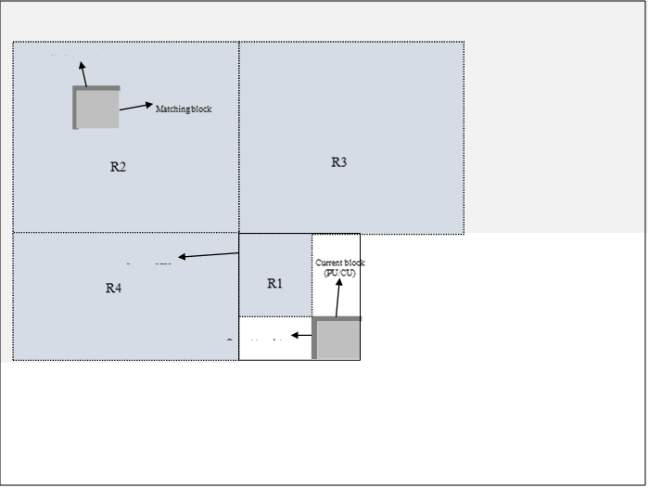
Figure 1. Intra template matching search area used.

Proposed method
The proposed method introduces three additional intraTMP modes: left template, above template and L-shape fusion mode. The new modes can be classified to two types: additional template type and fusion among candidates.
In addition to L-shape (left and above templates), using only left and only above templates as shown in Fig.2 is proposed. The size of the left and above templates is the same as in the L-shape template, which allows the cost calculation to be reused in the template matching process without increasing any SAD computation.
In ECM-7.0, template matching process uses two-step search method which the first step searches in the search range with step size 2, then a second refinement search is performed around the best position from the first step. In the proposed method, left and above template share the main search with L-shape but have its independent refinement search.
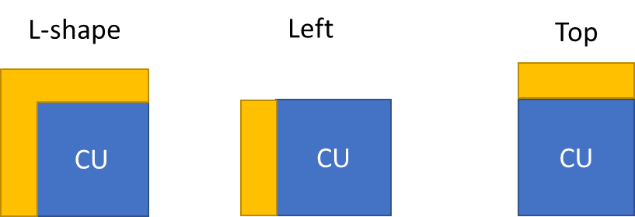
Figure 2. Illustration of left template and top template.
The other proposed new mode is the fusion among two L-shape candidates. In this method, L-shape template matching saves 2 best candidates instead of 1 with the minimum costs. In the prediction generating stage, the predictor of the 2 candidates are linearly combined. The formula of the combination is described in the following:
$$P_{\left(x, y\right)}=\frac{\left({cost}_{1}* P_{0 \left(x, y\right)}+{cost}_{0}* P_{1 \left(x, y\right)}\right)}{({cost}_{0}+ {cost}_{1})}$$Where P₀ and P₁ are the predictors which copied from the best and second best L-shape candidates, cost₀ and cost₁ are the costs of the two candidates obtained from the template matching process.

To signal the new modes, if intraTMP is used in the current CU, two flags are further signalled to indicate whether the L-shape template with fusion, left or above templates are applied as detailed in the below table.
IntraTMP modes | Signalling
L-shape | 00
L-shape with fusion | 01
Left template | 10
Above template | 11

Experiment Result
The simulation results in AI and RA conditions are show in table1 and table 2. Note that the encoding/decoding time may not be accurate in the results. The decoding in AI is relaunched to get the more accurate results.

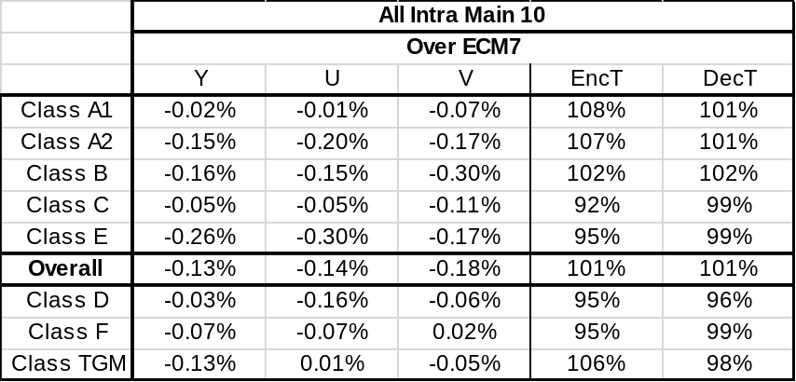
Table.1 The results of the proposed method in AI condition
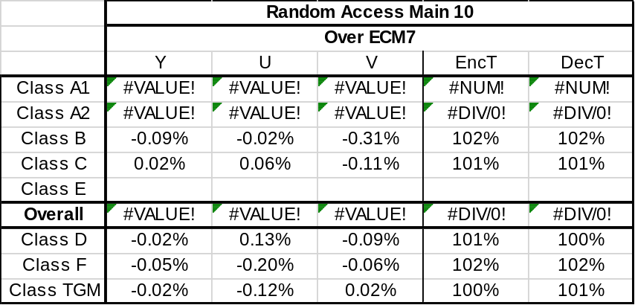
Table.2 The results of the proposed method in RA condition

Conclusion
The simulation results shows -0.13%/-0.14%/-0.18%gain on Y/Cb/Cr with 101%/101%encoding/decoding time in AI condition.

Patent rights declaration(s)
Qualcomm may have current or pending patent rights relating to the technology described in this contribution and, conditioned on reciprocity, is prepared to grant licenses under reasonable and non-discriminatory terms as necessary for implementation of the resulting ITU-T Recommendation | ISO/IEC International Standard (per box 2 of the ITU-T/ITU-R/ISO/IEC patent statement and licensing declaration form).

Reference
[1] V. Seregin, J. Chen etc, “Exploration Experiment on Enhanced Compression beyond VVC capability (EE2), ” JVET-AB2024, Joint Video Experts Team (JVET) of ITU-T SG 16 WP 3 and ISO/IEC JTC 1/SC 29, 28th Meeting: Mainz, DE, 20–28 October 2022.

