    Joint Video Experts Team (JVET)  of ITU-T SG 16 WP 3 and ISO/IEC JTC 1/SC 29  29th Meeting, by teleconference, 11–20 January 2023 | Document: JVET-AC0181-v1

Title: | AHG4: experiments in preparation of film grain visual tests
Status: | Input document to JVET
Purpose: | Information
Author(s) or  Contact(s): | P. de Lagrange | Email: | philippe.delagrange@interdigital.com
Source: | InterDigital
_____________________________

Abstract
This document reports about some experiments in preparation of visual tests planned in JVET-AB2022 for FGC SEI visual tests on top of VVC, more specifically the first category which goal is to assess the visual improvement brought by film grain synthesis over a wide range of coding quality. Three sequences that originally contain grain have been encoded with the VTM at every QP from 12 to 51, and checked visually to find when grain is just preserved, when grain is fully removed by encoding alone, and the QP range useful for visual assessment.

Sequences used for experiments
As stated in JVET-AB2022, test sequences preferably contain film grain or similar camera noise, so that grain added by synthesis does not disturb the opinion of viewers. Sequences used for experiments are:
- Two outdoor scenes from the 2004 SVT Multiformat Test Set (also known as “FairyTale”), shot on Kodak Vision 250D film and scanned at UHD resolution. The grain is coming from the actual film stock, the scanner being virtually noise-free, but with some digital clipping in highlights and shadows. Each pixel covers about 8.3µm of the film.
- One indoor scene from the 2015 Netflix Chimera test sequence, shot with a RED Epic Dragon digital camera at 4096x2160 resolution. This scene is said to attempt to recreate a codec-challenging sequence from House of Cards. The grain is coming from digital camera noise, which has different characteristics from the two test sequences from SVT.
Table 1 – Test sequences
Test sequence & format | Thumbnail
CrowdRun (from SVT FairyTale)  3840×2160, 50fps, 500 frames  Kodak Vision 250D film | 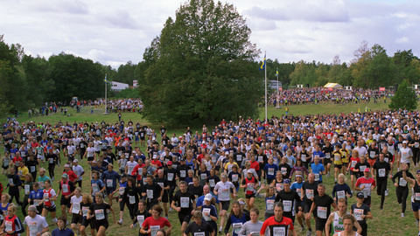
OldTownCross (from SVT FairyTale)  3840×2160, 50fps, 500 frames  Kodak Vision 250D film | 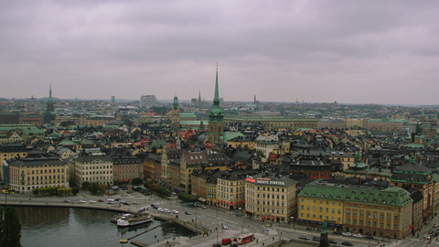
DinnerScene (from Netflix Chimera)  4096×2160, 60fps, 600 frame  RED Epic Dragon digital camera | 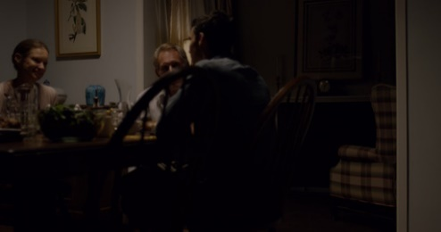

Test conditions
The sequences were encoded with VTM 17.0, using random-access default configuration file (that has MCTF on), and also with MCTF switched off. Every QP from 12 to 51 has been tested. It was noted that encoding at QPs below ~20 was painfully slow.
Encoded sequences were then decoded as yuv files, and played out to a 55’ LG OLED TV. The process started with playing the source then all QPs from 12 to 51 back to back, to get a first idea the useful QP range. Then typically the source then 2 or 3 selected QPs were played, potentially repeating the sequence, and potentially at reduced frame rate, to carefully check the quality. A few individual frames were also checked.
The goal was to find:
- Where grain just starts to be impaired by encoding (or is “just preserved”), with rating close to 10
- Where grain is removed, but the underlying content hopefully very well preserved (rating close to 9), the encoder acting as a denoiser
- The QP range useful for visual quality assessment (rating typically from 2 to 9)

General comments
It is observed that R/D curves exibit a flat region where PSNR does not vary much while bitrate increases a lot; this corresponds to the bitrate increase needed to starting coding correctly the noise or grain. Above that area (lower QPs), the R/D curve is straight, showing the R/D behaviour of grain coding. Below that area (higher QPs), the R/D curve show the behaviour of underlying video content coding.
This flat area is also where MCTF has the most impact, with up to 5x bitrate decrease with minor impact on quality. It is noted that MCTF has no impact at QP below 17 (coding matches exactly), which was expected since MCTF filtering strength depends on QP and is zero below a certain point.
Grain starts to be impaired at QP 16 for SVT sequences, and QP 14 for DinnerScene (not surprising since grain/noise has lower amplitude).
Grain is fully removed at QP 27 for SVT sequences, and QP 24 for DinnerScene. The loss of detail becomes detectable around QP 25 to 27; this matches the expectation of a point where grain is removed but underlying content is still coded with very high quality (encoder acting as a denoiser).
In the 16 to 26 QP range, grain is gradually impaired in an uneven fashion which can be visually disturbing.

CrowdRun
This sequence has high spatial and temporal complexity, with a less pronounced flat region on R/D curve than other sequences. Grain is prominent on light areas like the cloudy sky and white house. Only PSNR-Y is shown here (chroma PSNR is similar). Loss of detail is slightly detectable (e.g. on the rock below the central tree) at QP 27, where grain is completely removed (except on intra frames, which is not visually detectable). This threshold of QP 27 is the same with or without MCTF.
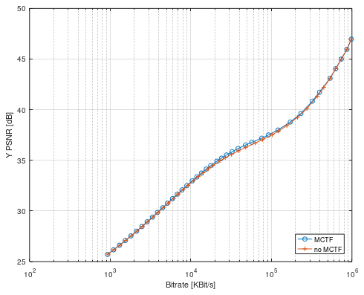
Figure 1 – Rate/PSNR plot for CrowdRun
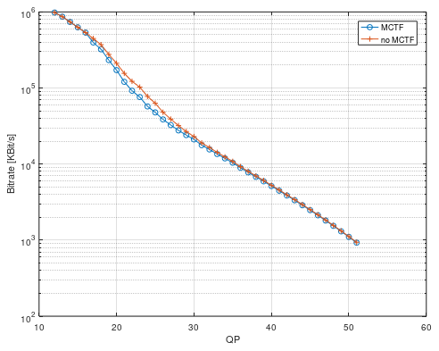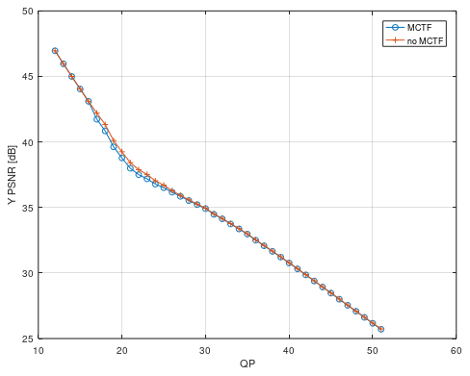
[2 .. 9] rating
Clean (QP=27)
Grain attenuation detectable (QP=16)
Figure 2 – QP/Rate and QP/PSNR plots for CrowdRun

OldTownCross
This sequence has low motion (camera moving forward) and high detail. Here the flat area on R/D curve is obvious, spanning two orders of magnitude: 100x the bitrate of high quality coding is needed to correctly code the grain. A very slight loss of detail is detectable (e.g. on dark roofs) at QP 27, where grain is completely removed (except on intra frames).
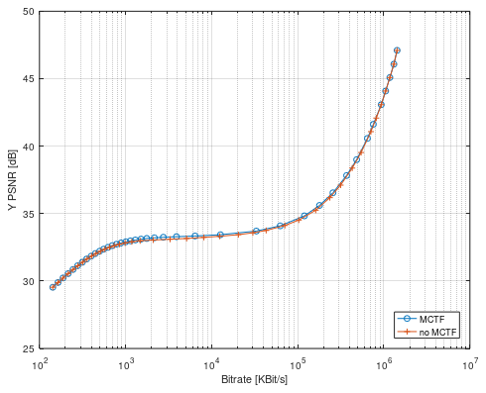
Figure 3 – Rate/PSNR plot for OldTownCross
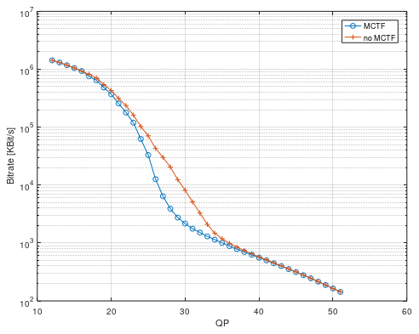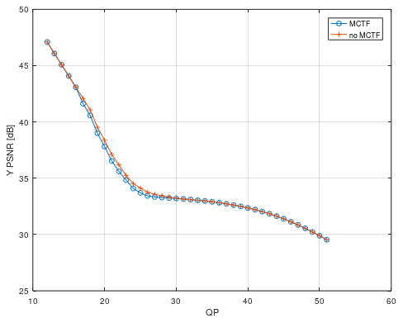
Grain attenuation detectable (QP=16)
[2 .. 9] rating
Clean (QP=27)
Figure 4 – QP/Rate and QP/PSNR plots for OldTownCross

DinnerScene
This sequence is dark, has very low motion (slow camera move, characters speaking), a few detailed zones, and large areas with subtle gradients where noise is prominent.
As for OldTownCross, the flat area on R/D curve is obvious. Noise starts to be impaired at QP 15, and is fully removed at QP 24 (with MCTF on). In between, noise impairment is visually unpleasing, with banding and blocking effects which are much worse that noise fully preserved or fully removed.
Image is clean of noise at QP 24, with virtually no loss of detail. Detail degradation is subtle and very gradual from QP 25 to 29 where is starts to be significant (rating 8).
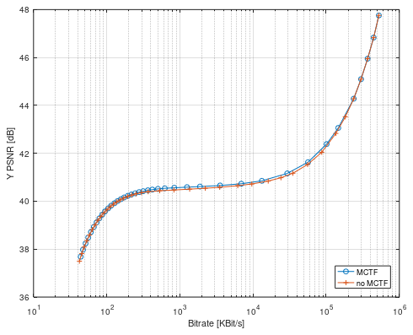
Figure 5 – Rate/PSNR plot for DinnerScene
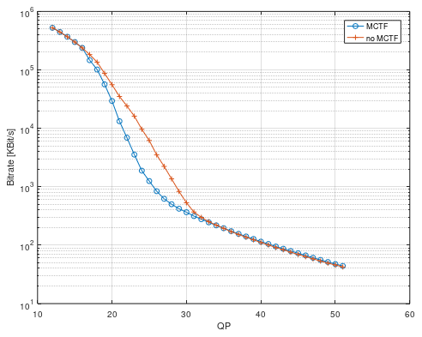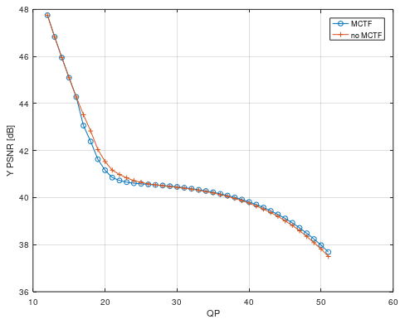
[2 .. 9] rating
Clean (QP=24)
Slight grain attenuation detectable (QP=14)
Figure 6 – QP/Rate and QP/PSNR plots for DinnerScene

