    Joint Video Experts Team (JVET)  of ITU-T SG 16 WP 3 and ISO/IEC JTC 1/SC 29  29th Meeting, by teleconference, 11–20 January 2023 | Document: JVET-AC0169-v1

Title: | Non-EE2: Template Matching for RR-IBC
Status: | Input document to JVET
Purpose: | Proposal
Author(s) or  Contact(s): | ¹Chun-Chi Chen, ²Han Huang, Zhi Zhang, ³Vadim Seregin, Marta Karczewicz  5775 Morehouse Dr, San Diego, CA 92121 USA | Email: | ¹chunchic@qti.qualcomm.com ²hanhuang@qti.qualcomm.com ³vseregin@qti.qualcomm.com
Source: | Qualcomm Inc.
_____________________________

Abstract
This contribution proposes to extend template matching (TM) to RR-IBC (reconstruction-reordering intra block copy). In ECM-7.0, template matching is applied to TM AMVP and TM MRG modes of IBC only when flipping is disabled for IBC blocks. This contribution enables TM, that ECM-7.0 uses currently, for IBC CU’s with horizontal or vertical flipping type. Firstly, the template blocks are flipped horizontally or vertically before template matching cost is computed, and then the search process of template matching can be reused completely for BV refinement. Experimental results are summarized below.
- AI Class F : (Y) -0.05%, (U) 0.13%, (V) 0.11%, (EncT) 100%, (DecT) 100%
- AI Class TGM : (Y) -0.03%, (U) 0.01%, (V) -0.02%, (EncT) 100%, (DecT) 100%
- RA Class F : (Y) -0.07%, (U) -0.34%, (V) -0.04%, (EncT) 100%, (DecT) 99%
- RA Class TGM: (Y) 0.02%, (U) -0.10%, (V) 0.06%, (EncT) 101%, (DecT) 100%
- LB Class F : (Y) -0.25%, (U) -0.38%, (V) -1.21%, (EncT) 100%, (DecT) 100%
- LB Class TGM: (Y)-0.04%, (U) 0.11%, (V) 0.13%, (EncT) 100%, (DecT) 101%

Introduction
In ECM-7.0, template matching (TM) is applied to non-flipped candidates of TM AMVP and TM MRG modes. In Figure 1, TM performs to search around an initially given BV candidate within a small range on the coded area of the current frame, and update BV based on whichever searched BV’s could reach the lowest TM cost. However, ECM-7.0 does not support applying TM to RR-IBC. Specifically, TM does not apply to refining and reordering AMVP candidates of IBC when horizontal or vertical flip mode is used; the derivation process of IBC MRG candidates has to rely on the TM flag value to determine whether the flip mode of a candidate can be inferred, which requires 30 (e.g., 5 from spatial candidates and 25 from HMVP candidates) branch condition checks. These extra processes are used to avoid applying TM to RR-IBC and can be avoided if ECM could support TM for RR-IBC.
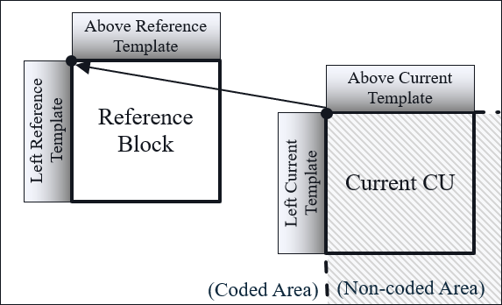
- Template matching based IBC.

Proposed method
The template shape of IBC is extended to horizontal and vertical types and the same TM search process of IBC can be applied. As Figure 2 illustrates, the template blocks can now be flipped horizontally or vertically. Since TM for RR-IBC is supported, the restriction (that TM does not perform for RR-IBC) imposed on TM is removed. Thus, TM can now be applied to refining and reordering IBC AMVP candidates, and the derivation process of TM MRG candidates for IBC no loner needs checking TM flag to determine what information should be discarded from candidates.
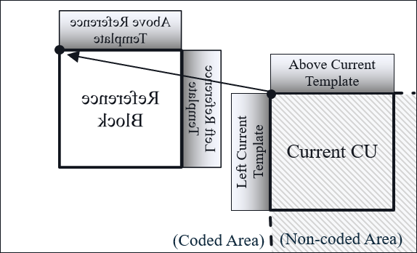 | 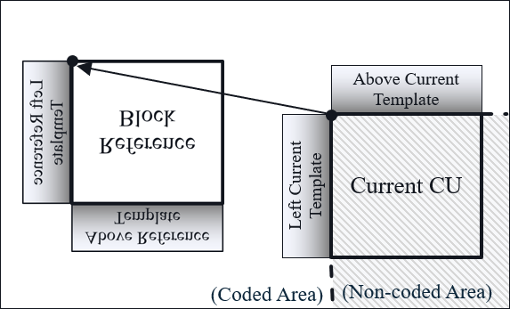
(a) Horizontal mode | (b) Vertical mode
- Templates and reference block of IBC with horizontal and vertical flip modes.

Experimental results
The proposed method was implemented on top of the ECM-7.0 software and tested based on the common test condition as specified in the Exploration Experiments 2 document (JVET-AB2024). The test results are summarized below.
- Performance results of the proposed method relative to ECM-7.0.
 | All Intra Main 10
 | Y | U | V | EncT | DecT
Class F | -0.05% | 0.13% | 0.11% | 100% | 100%
Class TGM | -0.03% | 0.01% | -0.02% | 100% | 100%
 | Random Access Main 10
Class F | -0.07% | -0.34% | -0.04% | 100% | 99%
Class TGM | 0.02% | -0.10% | 0.06% | 101% | 100%
 | Low delay B Main 10
Class F | -0.25% | -0.38% | -1.21% | 100% | 100%
Class TGM | -0.04% | 0.11% | 0.13% | 100% | 101%

Patent rights declaration(s)
Qualcomm Inc. may have current or pending patent rights relating to the technology described in this contribution and, conditioned on reciprocity, is prepared to grant licenses under reasonable and non-discriminatory terms as necessary for implementation of the resulting ITU-T Recommendation | ISO/IEC International Standard (per box 2 of the ITU-T/ITU-R/ISO/IEC patent statement and licensing declaration form).

