    Joint Video Experts Team (JVET)  of ITU-T SG 16 WP 3 and ISO/IEC JTC 1/SC 29  29th Meeting, by teleconference, 11–20 January 2023 | Document: JVET-AC0148-v1

Title: | Non-EE2: CCCM using multiple downsampling filters
Status: | Input document to JVET
Purpose: | Proposal
Author(s) or  Contact(s): | Yao-Jen Chang, Vadim Seregin, Marta Karczewicz | Email: | yjchang@qti.qualcomm.com
Source: | Qualcomm Inc.
_____________________________

Abstract
In this contribution, it is proposed to apply multiple downsampling filters to reconstructed luma samples corresponding to the prediction shape of a convolutional cross-component model for chroma intra prediction. The linear combination of these variously downsampled samples separately multiplied by derived coefficients composes a chroma predictor. The experimental results over ECM-7.0 are summarized as follows:
AI: xx % (Y), xx % (U), xx % (V), 10x % (EncT), xx % (DecT)
AI-TGM: -0.75 % (Y), -1.14 % (U), -1.37 % (V), 101 % (EncT), 100 % (DecT)
RA: xx % (Y), xx % (U), xx % (V), 10x % (EncT), xx % (DecT)
RA-TGM : xx % (Y), xx % (U), xx % (V), 10x % (EncT), xx % (DecT)

Introduction
Convolutional cross-component mode (CCCM) in ECM [1] applies a single downsampling filter to reconstructed luma samples corresponding to the cross prediction shape. The downsampled samples as well as a nonlinear term and a bias term are then combined together with filter coefficients to calculate the predicted chroma value. The filter coefficients are derived using LDL decomposition.

Proposed method
It is proposed to apply multiple downsampling filters to a group of reconstructed luma samples in a CCCM. The linear combination of these downsampled reconstructed samples is multiplied by derived filter coefficients to form the final chroma predictor. The coefficients are derived by LDL decomposition as currently used by CCCM and GLM in ECM. The cross-component models shown below are tested as additional CCCM modes:
- Model 1: predChroma = c0 * H(C) + c1 * G1(C) + c2 * G2(C) + c3 * G3(C) + c4 * G4(C) + c5 * P + c6 * B
- Model 2: predChroma = c0 * H(C) + c1 * H(W) + c2 * H(E) + c3 * G1(C) + c4 * G1(W) + c5 * G1(E) + c6 * B
- Model 3: predChroma = c0 * H(C) + c1 * H(N) + c2 * H(S) + c3 * G2(C) + c4 * G2(N) + c5 * G2(S) + c6 * B
- Model 4: predChroma = c0 * H(C) + c1 * H(NE) + c2 * H(SW) + c3 * G4(C) + c4 * G4(NE) + c5 * G4(SW) + c6 * B
where H(·), G1(·), G2(·), G3(·), G4(·) are various downsampling filters as indicated in Figure 1, C denotes the current chroma sample position, and N, S, W, E, NE, SW are the positions around C as indicated in Figure 2, c0, c1, …, c6 are filter coefficients, and P and B are nonlinear term and bias term. It is noted that Model 1 is a 1x1 prediction shape using current chroma sample only while the other models are one-directional prediction models using 3 chroma samples.
In this contribution, the proposed cross-component models are added to ECM as additional CCCM modes, and the choice of the CCCM models are signaled in the bitstream.

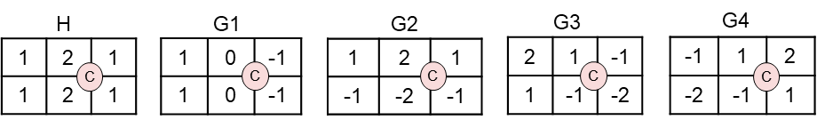
Figure 1. Various downsampling filters used in the proposed cross-component models

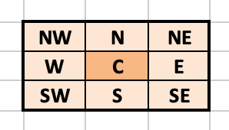
Figure 2. The positions of chroma samples

Experimental results
The proposed method was tested on top of ECM-7.0 under the common test conditions [2]. Table 1 shows the performance results.
Table 1. Performance results
 | AI |  |  |  |  | RA
 | Y | U | V | EncT | DecT | Y | U | V | EncT | DecT
Class A1 | 0.00% | -1.12% | -1.09% | 105% | 101%
Class A2
Class B | -0.01% | -1.25% | -1.01% | 102% | 99%
Class C | -0.04% | -0.90% | -0.81% | 103% | 98%
Class E | -0.01% | -0.77% | -0.39% | 103% | 99%
Overall
Class D | -0.02% | -0.97% | -0.63% | 103% | 99%
Class F | -0.19% | -1.07% | -0.98% | 100% | 100%
Class TGM | -0.75% | -1.14% | -1.37% | 101% | 100%

Conclusion
This contribution proposes to apply multiple downsampling filters to a group of reconstructed luma samples in a CCCM. The results show that CCCM can be further improved, and it is suggested to study the proposed method in EE2.

References
- M. Coban, F. Le Léannec, R.-L. Liao, K. Naser, J. Ström, and L. Zhang, “Algorithm description of Enhanced Compression Model 7 (ECM 7),” JVET-AB2025, Dec. 2022.
- M. Karczewicz, Y. Ye, “Common Test Conditions and evaluation procedures for enhanced compression tool testing”, JVET-Y2017, Jan. 2022.

Patent rights declaration(s)
Qualcomm Incorporated may have current or pending patent rights relating to the technology described in this contribution and, conditioned on reciprocity, is prepared to grant licenses under reasonable and non-discriminatory terms as necessary for implementation of the resulting ITU-T Recommendation | ISO/IEC International Standard (per box 2 of the ITU-T/ITU-R/ISO/IEC patent statement and licensing declaration form).

