    Joint Video Experts Team (JVET)  of ITU-T SG 16 WP 3 and ISO/IEC JTC 1/SC 29  29th Meeting, by teleconference, 11–20 January 2023 | Document: JVET-AC0146-v2

Title: | AHG12: Filtered Template Matching based Intra Prediction (FTMP)
Status: | Input document to JVET
Purpose: | Proposal
Author(s) or  Contact(s): | Ramin G. Youvalari  Döne Bugdayci Sansli  Pekka Astola  Jani Lainema | Email: | ramin.ghaznavi-youvalari@nokia.com  done.bugdayci_sansli@nokia.com  pekka.astola@nokia.com  jani.lainema@nokia.com
Source: | Nokia
_____________________________

Abstract
This contribution presents a template-matching based intra prediction mode for luma blocks, which is called Filtered Template Matching based intra Prediction (FTMP). Prediction is generated by applying a 6-tap filter on the reference block that is obtained from template-matching based search. The filter input consists of 5 spatial luma samples and a bias term. Filter coefficients are derived via regression based MSE minimization on reconstructed samples over the template areas of the current and reference blocks. The mode is signaled with a flag conditioned on intra TMP flag. The impact on coding efficiency and runtimes over ECM-7.0 is reportedly {for Y, U, V, EncT, DecT}:
AI { -0.14%, -0.15%, -0.19%, 105%, 101%}, RA { -0.04%, -0.04%, -0.11%, 101%, 100%}

Introduction
Intra template matching prediction (Intra TMP) copies a reference block from the reconstructed part of the current frame, whose L-shaped template matches the current template [2] . For a predefined search range, the encoder searches for the most similar template to the current template in a reconstructed part of the current frame and uses the corresponding block as a prediction block. The encoder then signals the usage of this mode, and the same prediction operation is performed at the decoder side. Sum of absolute differences (SAD) is used as the cost function during the search, and the mode is signaled at CU level through a dedicated flag when DIMD is not used for current CU.

The Intra template matching tool is enabled for CUs with size less than or equal to 64 in width and height respectively. This maximum CU size for Intra template matching is configurable.

Proposed Method
It is proposed to apply a filter on the intra template matching based prediction block to increase prediction accuracy and adapt the characteristics of the copied block to the local neighbourhood. Reconstructed luma samples over the template area of the reference block are used as inputs to the filter during training and corresponding luma sample in the template of the current block is the target. Parameters are derived using the regression based MSE minimization technique (i.e., LDL decomposition) existing in ECM and being utilized by other tools such as CCCM.
The proposed 6-tap filter takes spatial samples from the reconstructed reference block and uses middle value of the operating bit depth (e.g., 512 for 10-bit content) for bias. The formula for each new prediction sample is as follows:
predVal = c₀C + c₁N + c₂S + c₃W + c₄E + c₅b
The input to the spatial 5-tap component of the filter consists of a center (C) luma sample and its above/north (N), below/south (S), left/west (W) and right/east (E) neighbors as illustrated in Figure 1.
Template size and shapes are same as in intra TMP, the template size used for training is 4 lines above and to the left of the current block depending on their availability. Moreover, the search range for FTMP is also the same as intra TMP method.
Figure 1 illustrates the filter shape and training area where the green parts are the boundary region. Reconstructed samples in the boundary region are used in training when available and they are padded with closest available sample when unavailable.
The mode is signaled at CU level with a dedicated flag combined with the intra TMP flag. FTMP flag is inferred to be zero if intra TMP flag is 0.

Mode to be signaled | Intra TMP flag | FTMP flag
Intra Template Matching | 1 | 0
Filtered Template Matching | 1 | 1

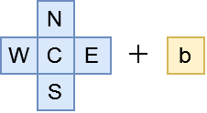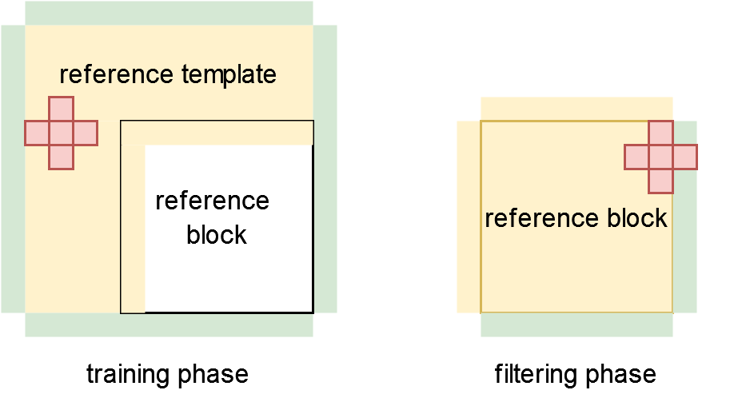
Figure 1. Filter shape and training area of the reference block.
The proposed method uses the current intra TMP SAD based search in ECM7.0 for creating a list of candidate reference blocks to be filtered. Entry to the candidate list is based on SAD cost of the unfiltered template.
The filter parameters are calculated for each candidate in the list and the best performing one in terms of template cost after filtering is selected and used as the final candidate. The final prediction of the block is then generated by applying the derived filter for the best candidate.

Simulation Results

Results for the main method
Tables below summarize the coding efficiency and runtime impact of the proposed method with maximum of 8 candidates in the list in ECM 7.0 using the JVET common test conditions [3].

 | All Intra Main10
 | Over ECM-7.0
 | Y | U | V | EncT | DecT
Class A1 | -0.01 % | -0.11 % | -0.05 % | 106 % | 100 %
Class A2 | -0.18 % | -0.24 % | -0.23 % | 107 % | 105 %
Class B | -0.16 % | -0.14 % | -0.21 % | 104 % | 101 %
Class C | -0.07 % | 0.01 % | -0.05 % | 104 % | 94 %
Class E | -0.30 % | -0.34 % | -0.44 % | 104 % | 105 %
Overall | -0.14 % | -0.15 % | -0.19 % | 105 % | 101 %
Class D | -0.01 % | -0.10 % | -0.02 % | 103 % | 98 %
Class F | -0.37 % | -0.16 % | -0.47 % | 102 % | 102 %
Class TGM | -0.11 % | -0.04 % | -0.05 % | 105 % | 101 %

 | Random Access Main 10
 | Over ECM-7.0
 | Y | U | V | EncT | DecT
Class A1 | -0.03 % | -0.19 % | 0.04 % | 101 % | 100 %
Class A2 | -0.06 % | -0.02 % | -0.15 % | 101 % | 101 %
Class B | -0.06 % | -0.03 % | -0.26 % | 100 % | 101 %
Class C | 0.01 % | 0.05 % | -0.01 % | 104 % | 100 %
Class E
Overall | -0.04 % | -0.04 % | -0.11 % | 101 % | 100 %
Class D | -0.03 % | -0.01 % | 0.16 % | 101 % | 101 %
Class F | -0.17 % | -0.17 % | -0.22 % | 102 % | 99 %
Class TGM | -0.03 % | -0.12 % | -0.01 % | 99 % | 98 %

Additional tests
The table below summarizes performance of different variants of the proposed method to demonstrate trade-offs provided by different number of intraTMP candidates for FTMP in All Intra configuration. Results include luma BD-rate impact for each class and separate averages for luma BD-rate impact (Y) and chroma BD-rate impact (UV).

Test 1: FTMP using max of 8 candidates in the parameter derivation list
Test 2: FTMP using max of 4 candidates in the parameter derivation list
Test 3: FTMP using max of 2 candidates in the parameter derivation list
Test 4: FTMP using max of 1 candidate in the parameter derivation list

vs. ECM 7.0 | Test 1 | Test 2 | Test 3 | Test 4
Class A1 | -0.01 % | 0.00 % | -0.01 % | 0.01 %
Class A2 | -0.18 % | -0.16 % | -0.14 % | -0.11 %
Class B | -0.16 % | -0.15 % | -0.13 % | -0.11 %
Class C | -0.07 % | -0.05 % | -0.05 % | -0.03 %
Class E | -0.30 % | -0.27 % | -0.23 % | -0.18 %
Average Y | -0.14 % | -0.12 % | -0.11 % | -0.08 %
Average UV | -0.17 % | -0.17 % | -0.12 % | -0.14 %
Class D | -0.01 % | -0.01 % | -0.02 % | 0.00 %
Class F | -0.37 % | -0.37 % | -0.39 % | -0.32 %
Class TGM | -0.11 % | -0.08 % | -0.08 % | -0.06 %

Conclusion
This contribution proposes filtered intraTMP method to further improve the coding efficiency of intra blocks in ECM-7.0. The experiments showed that the method provides 0.14% gain in AI configuration over ECM-7.0. It is suggested to study the proposed method in the next EE round.

References
- ECM-7.0 reference software, https://vcgit.hhi.fraunhofer.de/ecm/ECM.git
- Coban et.al, “Algorithm description of Enhanced Compression Model 7 (ECM 7)”, JVET-AB2025, Oct. 2022.
- M. Karczewicz, Y. Ye, “Common Test Conditions and evaluation procedures for enhanced compression tool testing”, JVET-Y2017, Jan. 2022.

Patent rights declaration(s)
NOKIA may have current or pending patent rights relating to the technology described in this contribution and conditioned on reciprocity, is prepared to grant licenses under reasonable and non-discriminatory terms as necessary for implementation of the resulting ITU-T Recommendation | ISO/IEC International Standard (per box 2 of the ITU-T/ITU-R/ISO/IEC patent statement and licensing declaration form).

