    Joint Video Experts Team (JVET)  of ITU-T SG 16 WP 3 and ISO/IEC JTC 1/SC 29  29th Meeting, by teleconference, 11–20 January 2023 | Document: JVET-AC0129-v1

Title: | AHG9: On the NNPFC SEI message update and activation
Status: | Input document to JVET
Purpose: | Proposal
Author(s) or  Contact(s): | Hendry  Junghak Nam  Hyeongmoon Jang  Seung hwan Kim  Jaehyun Lim | Email: | dr.hendry@lge.com  junghak.nam@lge.com
Source: | LG Electronics Inc.
_____________________________

Abstract
It is asserted that the current VSEI specification is not clear about which neural-network post-filter (NNPF) applies to a picture when an NNPFC SEI message containing an update filter is present, prior to the picture, in the bitstream after an NNPFC SEI message containing the base filter has been activated. The asserted problem in such situation is which filter to be applied to the picture, the base filter (i.e., the filter in the NNPFC SEI message that is present prior to the NNPFA SEI message) or the updated filter (i.e., the filter in the NNPFC SEI message that is present after the NNPFA SEI message).
In this contribution, three possible solutions were presented as follows:
- Specifying that the NNPF that applies to a picture is the one that is in the NNPFC that immediately precedes the picture in output order.
- Specifying that the NNPF that applies to a picture is the one that is in the NNPFC that immediately precedes the NNPFA in output order.
- Specifying that when an NNPFC SEI message is present, it cancels the persistence of previous NNPFA SEI message with the same ID, if present.
The authors proposed that option 2 (first choice) or option 3 (second choice) are used to solve the asserted problem.

Problem description
Neural-network post-filter characteristics (NNPFC) SEI message provides neural-network post-filter and neural-network post-filter activation (NNPFA) SEI message provides activation of the post-filter specified in NNPFC SEI message to a set of pictures. The NNPFA SEI message may specify that the target post-filter applies to the current picture only or to current pictures and subsequent pictures, in output order, until one of the following events happens:
– A new CLVS of the current layer begins.
– The bitstream ends.
– A picture in the current layer associated with a NNPFA SEI message with the same nnpfa_target_id as the current SEI message and nnpfa_cancel_flag equal to 1 is output that follows the current picture in output order.
The above design of signaling that involves NNPFC and NNPFA and persistent as described above is asserted to have problem in the situation illustrated in the figure below. In the given case example, a new NNPFC SEI message is present in the AU that contains PU with POC 3. This creates unclear situation whether neural-network post-filter applies to PU with POC 3. If yes, which NNPFC applies since the previous NNPFA activated the base NNPFC SEI but an update has been provided. In authors’ assessment, while there have been several SEI messages that use this persistency mechanism, the SEI message and its activation are in the same SEI message. On the other hand, for neural-network post-filter (NNPF), the post-filter and its activation are carried in two different SEI messages.
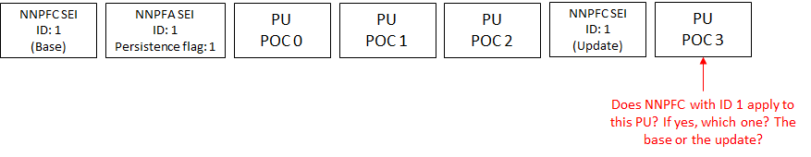
Figure 1 – Case when NNPFC update is present without NNPFA

Discussion and proposed solution
In our assertion, there may be possibilities that can be used to overcome the above situation. These possible solutions have pro and cons that should be discussed.

Solution option 1
It may be possible to overcome the asserted problem by specifying that the NNPF that applies to a picture is the one that is in the immediate NNPFC that precedes the picture in output order. Figure below illustrates this solution.
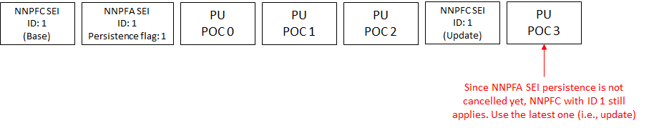
Figure 2 – Solution in which the presence of NNPFC does not cancel the persistence of NNPFA
and the updated filter is used right away.
This solution has advantage that it is simple. Once an NNPFC is activated it can be updated without the need of reactivation. However, there may be robustness concern such that if the updated filter in the 2nd NNPFC SEI message in the illustrated example above is missing, then decoder may apply incorrect NNPF to PU POC 3.

Solution option 2
It may be possible to overcome the asserted problem by specifying that the NNPF that applies to a picture is the one that is in the immediate NNPFC that precedes the NNPFA in output order. Figure below illustrates this solution.
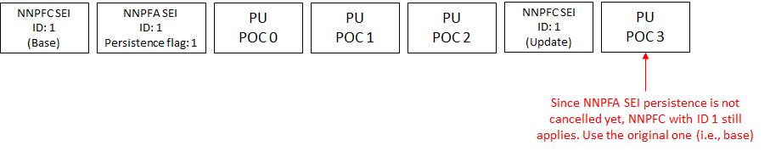
Figure 3 – Solution in which the presence of NNPFC does not cancel the persistence of NNPFA
and the updated filter is not used right away.
This solution provides a clear association between NNPFC and NNPFA. Once a particular NNPF is activated, it stays active until it is one of the three conditions is met (i.e., the bitstream ends, the CVLS ends, or a cancel NNPFA SEI message is present). There may be updates provided for the NNPF but the update will not be active until the current activation is cancelled and a new activation is present. This also make it very clear such that activation and cancellation of an active NNPF is done only by NNPFA SEI message. However, this requires that decoder needs to provide two storages of NNPFs with the same id, i.e., one for the one currently active and one for updated filter that is present after the activation.

Solution option 3
It may be possible to overcome the asserted problem by specifying that when an NNPFC SEI message is present, it cancel the persistence of previous NNPFA SEI message with the same ID, if present. Figure below illustrates this option.
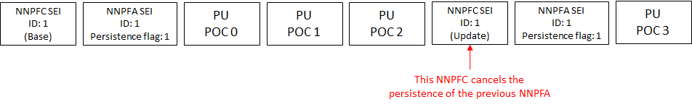
Figure 4 – Solution in which the presence of NNPFC cancels the persistence of NNPFA.
This solution is similar to the first possible solution but with different such that each NNPFC are used only when it is activated so it may address the robustness concern (i.e., decoder may apply wrong NNPF). If the NNPFC SEI message that contains the update is missing in the example above, decoder may infer that there may be missing SEI message when it sees the new NNPFA SEI message. When NNPFC SEI message that contains the update is present but the new NNPFA SEI message is missing, the updated NNPF will not be applied to PU POC 3, assuming that it is better not to do anything rather than applying wrong filter.

Proposed solution
Considering the possible solutions discussed above, our recommendation is to use solution option 2 (first choice) or solution option 3 (second choice). In our assessment, solution option 2 provides a clean solution such that activation and cancellation are handled by NNPFA SEI message only. Furthermore, it also has clear association between NNPFA and the NNFPC that it activates.
Figure 5 below illustrates the example of the application of multiple NNPFC SEI messages with the same nnpfc_id and they are activated at different positions. With solution option 2, update filters can be signal when at any point and they are activated only when a new NNPFA SEI message with nnpfa_cancel_flag equal to 0 is outputted.
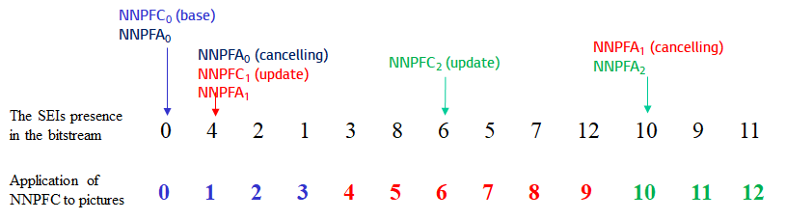
Figure 5 – Illustration of the application of multiple NNPFC of the same nnpfc_id activated at different position based on solution option 2.

Text implementation

Option 1

Neural-network post-filter activation SEI
nn_post_filter_activation( payloadSize ) { | Descriptor
nnpfa_target_id | ue(v)
nnpfa_cancel_flag | u(1)
if( !nnpfa_cancel_flag ) {
nnpfa_persistence_flag | u(1)
}

…
nnpfa_persistence_flag specifies the persistence of the target neural-network post-processing filter for the current layer.
nnpfa_persistence_flag equal to 0 specifies that the target neural-network post-processing filter may be used for post-processing filtering for the current picture only.
nnpfa_persistence_flag equal to 1 specifies that the target neural-network post-processing filter may be used for post-processing filtering for the current picture and all subsequent pictures of the current layer in output order until one or more of the following conditions are true:
– A new CLVS of the current layer begins.
– The bitstream ends.
– A picture in the current layer associated with a NNPFA SEI message with the same nnpfa_target_id as the current SEI message and nnpfa_cancel_flag equal to 1 is output that follows the current picture in output order.
NOTE 2 – The target neural-network post-processing filter is not applied for this subsequent picture in the current layer associated with a NNPFA SEI message with the same nnpfa_target_id as the current SEI message and nnpfa_cancel_flag equal to 1.
When a NNPFA SEI message pertains to the current picture, the target neural-network post-processing filter for the current picture is the filter that is provided in the NNPFC SEI message that immediately precedes that current picture in output order and with nnpfc_id equal to the nnpfa_target_id.

Option 2

Neural-network post-filter activation SEI
nn_post_filter_activation( payloadSize ) { | Descriptor
nnpfa_target_id | ue(v)
nnpfa_cancel_flag | u(1)
if( !nnpfa_cancel_flag ) {
nnpfa_persistence_flag | u(1)
}
…
nnpfa_persistence_flag specifies the persistence of the target neural-network post-processing filter for the current layer.
nnpfa_persistence_flag equal to 0 specifies that the target neural-network post-processing filter may be used for post-processing filtering for the current picture only.
nnpfa_persistence_flag equal to 1 specifies that the target neural-network post-processing filter may be used for post-processing filtering for the current picture and all subsequent pictures of the current layer in output order until one or more of the following conditions are true:
– A new CLVS of the current layer begins.
– The bitstream ends.
– A picture in the current layer associated with a NNPFA SEI message with the same nnpfa_target_id as the current SEI message and nnpfa_cancel_flag equal to 1 is output that follows the current picture in output order.
NOTE 2 – The target neural-network post-processing filter is not applied for this subsequent picture in the current layer associated with a NNPFA SEI message with the same nnpfa_target_id as the current SEI message and nnpfa_cancel_flag equal to 1.
When a NNPFA SEI message pertains to the current picture, the target neural-network post-processing filter for the current picture is the filter that is provided in the first NNPFC SEI message that immediately precedes that NNPFA SEI message, in output order, and with nnpfc_id equal to the nnpfa_target_id.

Option 3

Neural-network post-filter activation SEI
nn_post_filter_activation( payloadSize ) { | Descriptor
nnpfa_target_id | ue(v)
nnpfa_cancel_flag | u(1)
if( !nnpfa_cancel_flag ) {
nnpfa_persistence_flag | u(1)
}
…
nnpfa_persistence_flag specifies the persistence of the target neural-network post-processing filter for the current layer.
nnpfa_persistence_flag equal to 0 specifies that the target neural-network post-processing filter may be used for post-processing filtering for the current picture only.
nnpfa_persistence_flag equal to 1 specifies that the target neural-network post-processing filter may be used for post-processing filtering for the current picture and all subsequent pictures of the current layer in output order until one or more of the following conditions are true:
– A new CLVS of the current layer begins.
– The bitstream ends.
– A picture in the current layer associated with a NNPFA SEI message with the same nnpfa_target_id as the current SEI message and nnpfa_cancel_flag equal to 1 is output that follows the current picture in output order.
NOTE 2 – The target neural-network post-processing filter is not applied for this subsequent picture in the current layer associated with a NNPFA SEI message with the same nnpfa_target_id as the current SEI message and nnpfa_cancel_flag equal to 1.
– A picture in the current layer associated with a NNPFC SEI message with nnpfa_id equal to the nnpfa_target_id as the current SEI message is output that follows the current picture in output order.
NOTE 3 – The target neural-network post-processing filter is not applied for this subsequent picture in the current layer associated with that new NNPFC SEI message.
NOTE 4 – A new NNPFA SEI message with the same nnpfa_target_id may be present in this subsequent picture in the current layer in which the target neural-network post-processing filter that applies to that subsequent picture is the filter in the new NNPFC SEI message.

Patent rights declaration(s)
LG Electronics Inc. may have current or pending patent rights relating to the technology described in this contribution and, conditioned on reciprocity, is prepared to grant licenses under reasonable and non-discriminatory terms as necessary for implementation of the resulting ITU-T Recommendation | ISO/IEC International Standard (per box 2 of the ITU-T/ITU-R/ISO/IEC patent statement and licensing declaration form).

