    Joint Video Experts Team (JVET)  of ITU-T SG 16 WP 3 and ISO/IEC JTC 1/SC 29  29th Meeting, by teleconference, 11–20 January 2023 | Document: JVET-AC0103-v3

Title: | Non-EE2: AMVP mode with subblock-based temporal motion vector prediction
Status: | Input document to JVET
Purpose: | Proposal
Author(s) or  Contact(s): | Ru-Ling Liao  Jie Chen  Yan Ye  Xinwei Li | Tel:  Email: | {ruling.lrl, jiechen.cj, yan.ye, sid.lxw}@alibaba-inc.com
Source: | Alibaba group
_____________________________

Abstract
This contribution proposes to apply SbTMVP to AMVP mode. Given a CU coded in AMVP with SbTMVP mode, the CU is predicted using a similar way to that of SbTMVP in merge mode except that the motion shift is signaled in the bitstream instead of deriving from left neighboring block. The motion shift comprises a derived MVP and a signaled MVD, and the MVD only has 32 candidates which are composed of 8 motion directions and 4 motion magnitudes. It is reported that on top of ECM-7.0, the overall coding performance impact for {Y, U, V, EncT, DecT} is {-0.10%, -0.08%, -0.12%, 104%, 100%} for RA and {-0.28%, -0.49%, -0.53%, 104%, 101%} for LB.

Introduction
In ECM-7.0, when a CU coded using subblock-based temporal motion vector prediction (SbTMVP), it is firstly split into 4x4 subblocks. Then, each subblock derives its own motion vector from a corresponding subblock in collocated picture. The corresponding subblock is obtained using a motion shift derived from left spatial neighboring block. The SbTMVP is only allowed in the merge mode in current ECM. To utilize the benefits of SbTMVP, this contribution proposes to extend SbTMVP to AMVP mode.

Proposed methods
In this contribution, it is proposed to extend collocated CTU to collocated CTU row for SbTMVP and apply SbTMVP to AMVP mode. When a CU is coded using the proposed mode, the CU is split into 4x4 subblocks, and each subblock derives its own motion from a corresponding subblock in the collocated picture. The corresponding subblock is obtained using MVP with a signaled MVD. The MVP is derived in the similar way to that of MVP of normal AMVP mode. Specifically, when calculating the TM cost in MVP derivation process, the template is predicted using collocated TMVP and is predicted at 4x4 subblock level. The signaled MVD is constrained to one of 32 candidates which comprise 8 motion directions (as shown in Figure 1) and 4 motion magnitudes (i.e. {4-pel, 8-pel, 16-pel, 32-pel}). In some cases, the corresponding subblock in collocated picture is non-inter coded, that is, the temporal motion information is unavailable; in this case, the motion of center subblock of the CU is used instead. When the motion of the center subblock of the CU is also unavailable, the MVP with the signaled MVD is used instead
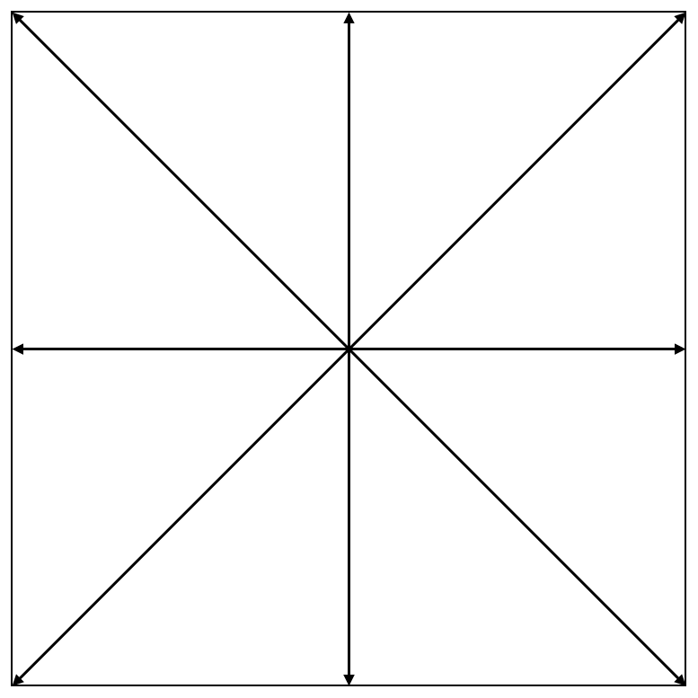
Figure 1. 8 motion directions for the proposed mode.
Regarding the syntax design, when a CU coded using AMVP mode, a flag is signaled to indicate whether the CU is predicted with SbTMVP. If the SbTMVP is used, another flag is signaled to indicate whether MVD exists, and an MVD index is signaled to indicate the motion direction and motion magnitude if MVD exists. The inter prediction direction and reference picture index are directly set to the collocated picture instead of being signalled in the bitstream for the proposed mode. Moreover, the adaptive motion vector resolution (AMVR), local illumination compensation (LIC) and multi-hypothesis prediction (MHP) are not applied to the proposed mode.

Simulation results
The proposed methods are implemented on top of ECM-7.0 and are tested under CTC for enhanced compression tool testing [1] with random access and low delay B configurations.
Table 1. Simulation results of proposed methods
 | Random access Main10
 | Over ECM-7.0
 | Y | U | V | EncT | DecT
Class A1 | -0.10% | -0.13% | -0.03% | 104% | 100%
Class A2 | -0.07% | -0.01% | -0.08% | 105% | 100%
Class B | -0.06% | -0.03% | -0.16% | 104% | 101%
Class C | -0.19% | -0.17% | -0.15% | 104% | 101%
Class E
Overall | -0.10% | -0.08% | -0.12% | 104% | 101%
Class D | -0.11% | -0.18% | -0.28% | 104% | 101%
Class F | -0.08% | -0.15% | 0.02% | 102% | 100%

 | Low delay B Main10
 | Over ECM-7.0
 | Y | U | V | EncT | DecT
Class A1
Class A2
Class B | -0.13% | -0.24% | -0.78% | 106% | 103%
Class C | -0.30% | -0.30% | -0.35% | 102% | 99%
Class E | -0.50% | -1.17% | -0.36% | 103% | 98%
Overall | -0.28% | -0.49% | -0.53% | 104% | 101%
Class D | -0.33% | 0.19% | -0.38% | 106% | 103%
Class F | -0.15% | 0.03% | -0.66% | 101% | 98%

References
- M. Karczewicz and Y. Ye, “Common Test Conditions and evaluation procedures for enhanced compression tool testing,” JVET-Y2017, Feb. 2022.

Patent rights declaration(s)
Alibaba group may have current or pending patent rights relating to the technology described in this contribution and, conditioned on reciprocity, is prepared to grant licenses under reasonable and non-discriminatory terms as necessary for implementation of the resulting ITU-T Recommendation | ISO/IEC International Standard (per box 2 of the ITU-T/ITU-R/ISO/IEC patent statement and licensing declaration form).

