    Joint Video Experts Team (JVET)  of ITU-T SG 16 WP 3 and ISO/IEC JTC 1/SC 29  29th Meeting, by teleconference, 11–20 January 2023 | Document: JVET-AC0092-v2

Title: | AHG15: Investigations on the common test conditions of Video Coding for Machines (VCM)
Status: | Input document to JVET
Purpose: | Proposal
Author(s) or  Contact(s): | Shurun Wang,  Jie Chen,  Yan Ye,  Shiqi Wang | Email: | shurun.wsr@alibaba-inc.com  jiechen.cj@alibaba-inc.com  yan.ye@alibaba-inc.com  shiqwang@cityu.edu.hk
Source: | Alibaba and City University of Hong Kong
_____________________________

Abstract
This contribution illustrates the non-monotonic issue for machine task performance in the common test condition (CTC) of video coding for machines (VCM), which affects the ability for us to compare the performance of different proposals in an apple-to-apple manner. Specifically, the non-monotonic rate distortion behavior of various machine vision tasks are observed and illustrated in both some of the proposed technologies and the anchor. In this contribution, we investigate the CTC of VCM and propose three possible solutions to solve/alleviate this issue.

Introduction
It has been found that there are many non-monotonic results in the evaluation of video coding for machines (VCM) performance, which means the machine task performance is not monotonic with the coding bit overhead (bit per pixel or kbps). The non-monotonic phenomeneon could be observed in the VCM anchors as well, when VVC is used without modification for image/video compression. Fig. 1 shows the rate-machine vision performance on object detection for FLIR dataset and SFU-HW dataset Class E respectively, where VVC is used without modification to generate VCM anchors. The non-monotonic situations could result in an invalid BD-rate saving calculation. To side-step this non-monotonic problem, the BD-rate savings are set to -100% for non-monotonic situations in either the anchor or the proposal in the VCM CfP [1].
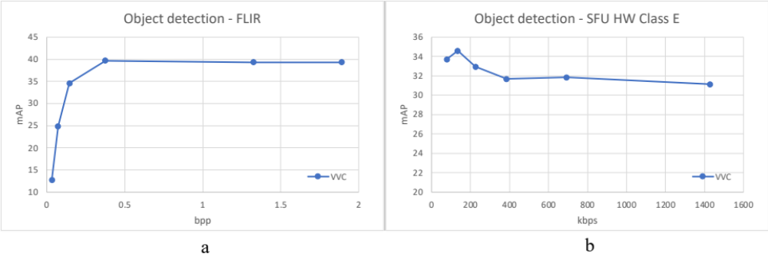
Fig. 1 The non-monotonic performance for object detection on FLIR dataset (a) and SFU HW dataset Class E (b) using VVC without mofidication as anchor.

However, this temporary solution leads to difficulties to compare different proposals. As shown in Fig. 2 as an example, the BD-rate savings of proposal 1 (denoted as M1) is set to -100%, which means M1 would be excluded for the technology comparison in terms of BD-rate saving, due to non-monotocity in rate distortion performance and proposal 2 (denoated as M2) achieves a -21.95% BD-rate savings compared with VVC. However, the compression efficiency of M1 is better than that of M2, in terms of the rate-machine vision performance curve.
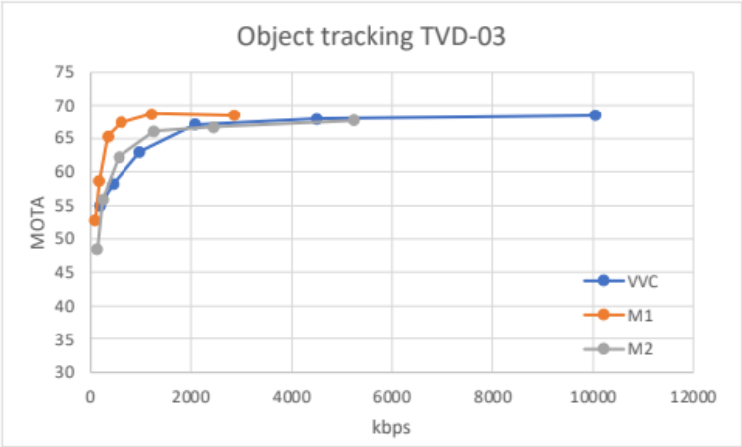
Fig. 2 An example of the comparison between non-monotonic and monotonic performance.

Proposal
In this section, we describe three possible solutions for the non-monotonic issue for machine vision task evaluation, which are detailed as follows. We note that none of these solutions seems to solve the issue identified with 100% satisfaction, and intend for this contribution to inspire discussion among experts such that better solution can be found.

Solution1
The first solution is to use BD-quality (which means BD-mAP for object detection and instance segmentation, and BD-MOTA for object tracking) to replace BD-rate as the evaluation metric for the effectiveness. Generally, BD-quality calculates the averaged quality improvement of the proposal compared with the anchor under the same coding bit overhead in an intergration manner. Similarly, BD-rate calculates the averaged coding bit overhead saving of the proposal compared with the anchor under the same performance. There is an example for the difference between BD-rate and BD-mAP calculation for non-monotonic results of proposal 3 (denoted as M3), shown in Fig. 3. The bpp-mAP performance of M3 is shown in Fig. 3(a). Fig. 3(b) illustrates the calculation of BD-rate saving. Specifically, the two red points X₁ and X₂ have the same mAP performance with different coding bit overhead, which causes the problem of intergration and the BD-rate saving would be -100% according to [1]. However, BD-mAP calculation shown in Fig. 3(c) is still feasible and the BD-mAP is 6.019312754.
Advantages: The calculation of BD-quality is still feasible when the machine vision performance is not monotonic along with the coding expense (bit per pixel (bpp) or bitrate).
Disadvantages: BD-mAP and BD-MOTA are not straightforward enough to understand the benefit quantitatively, compared with BD-rate.
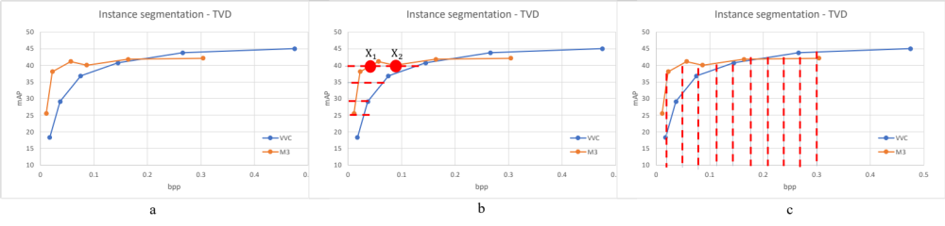
Fig. 3 The difference between BD-rate and BD-mAP calculation for non-monotonic results.

Solution2
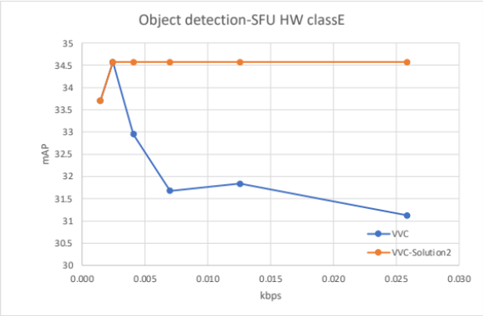
Fig. 4 An example of the difference between the original performance and the processed performance for Solution2 on SFU HW dataset Class E for object detection.
A second solution would process the non-monotonic data to achieve a monotonic performance, denoted as Solution2. Specifically, the tested performance points could be denoted as {($R_{i}, Q_{i}$)}, where $R_{i}$ and $Q_{i}$ indicates the coding expense and the machine vision performance (the larger the better) respectively. Regarding a non-monotonic point, which means $R_{j}<R_{j+1}$ but $Q_{j}>Q_{j+1}$, we could achieve monotonicity by replacing $Q_{j+1}$ with $Q_{j+1}^{'}$, where $Q_{j+1}^{'}=Q_{j}+ε$ and $ε$ is a small constant number. Effectively, solution 2 sends dummy bits, which is $R_{j+1}-R_{j}$, to achieve $R_{j+1}$ coding bit rate without degrading the machine vision performance $Q_{j}$ at $R_{j}$.
Advantages: The BD-rate calculation would be feasible for various non-monotonic solutions.
Disadvantages: Solution2 could result in drastic change to the real rate distortion performance. As shown in Fig. 4, the object detection performance of SFU HW class E of the VVC anchor is so far from monotonicity that there would be a very large gap between the rate distortion performance of the original data and the processed data.

Solution3
The third solution is to merge the datasets with the same machine vision task and evaluation metrics together, denoted as Solution3. To be specific, there are three machine vision tasks and four test datasets in VCM standardization of MPEG 4 and the detailed information of tasks and datasets are shown in Table 1. We have performed extensive experiments with Solution3 for object detection and instance segmentation respectively with VTM by merging the images and the ground truth labels together. Specifically, Open Images dataset (Oid) and TVD dataset are merged, since only this two datasets share the same machine vision tasks (detection and segmentation) and evaluation metrics for both coding expense and machine vision quality performance, shown in read bounding box in Table 1. It has been found that Solution3 could improve the monotonic property to some extent, which has been shown in Table 2. The detailed bpp-mAP curve for object detection and instance segmentation could be found in Fig. 5 and Fig. 6 respectively.

Table 1 The machine vision tasks and the test datasets information in VCM of MPEG4. The data format (image/video) and the number of image/sequence are also provided.
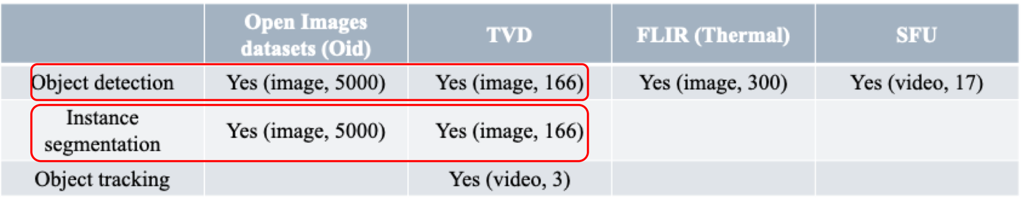

Table 2 The largest non-monotonic QP point value for various datasets and Solution3 on detection and segmentation, when VTM is adopted for image compression.

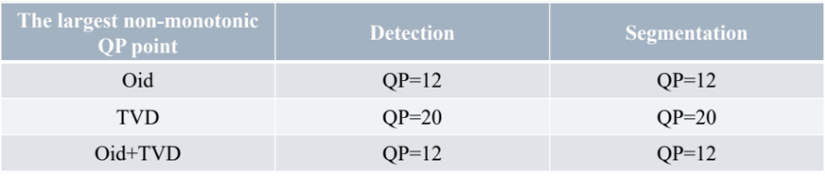

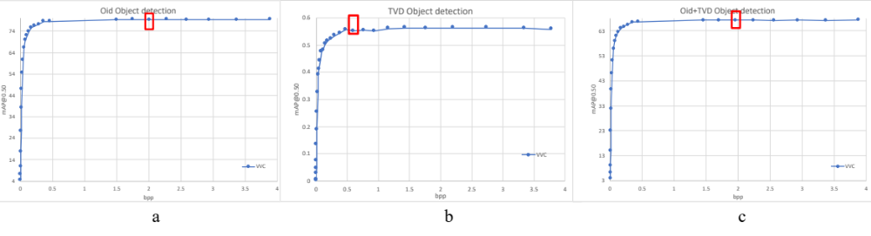
Fig. 5 The bpp-mAP performance for object detection on (a) Oid, (b) TVD and (c) Oid+TVD.
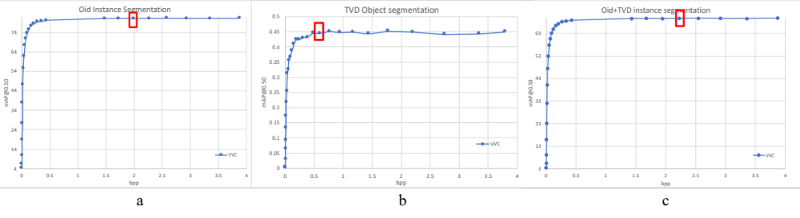
Fig. 6 The bpp-mAP performance for object detection on (a) Oid, (b) TVD and (c) Oid+TVD.
Solution3 could postpone the non-monotonic points from QP=20 to QP=12. However, in current CTC of VCM in MPEG 4, the six QP values for anchor generation are in range from 22 to 47, with delta QP = 5, which is still larger than the largest non-monotonic QP value, which is 20 on TVD dataset for detection and segmentation.

Conclusion
Considering the feasibility of various solutions for non-monotonic scenarios, it is suggested to use solution1 (BD-quality) as the VCM evaluation metric.

References
- WG2 group, “Common Test Conditions and Evaluation Methodology for Video Coding for Machines”, ISO/IEC JTC 1/SC 29/WG2 output document, N00192, July 2022, Online.

Patent rights declaration(s)
Alibaba and City University of Hong Kong may have current or pending patent rights relating to the technology described in this contribution and, conditioned on reciprocity, is prepared to grant licenses under reasonable and non-discriminatory terms as necessary for implementation of the resulting ITU-T Recommendation | ISO/IEC International Standard (per box 2 of the ITU-T/ITU-R/ISO/IEC patent statement and licensing declaration form).

