    Joint Video Experts Team (JVET)  of ITU-T SG 16 WP 3 and ISO/IEC JTC 1/SC 29  28th Meeting, Mainz, DE, 20–28 October 2022 | Document: JVET-AB0184

Title: | EE2-5.1: Extended Fixed-Filter-Output based Taps for ALF
Status: | Input document to JVET
Purpose: | Proposal
Author(s) or  Contact(s): | Wenbin Yin¹, Kai Zhang², Zhipin Deng¹, Li Zhang²  ¹Zijinshumayuan 4th building F9, 18 Zhongguancun Nansijie, Haidian District, 100190, Beijing, China  ²8910 University Center Lane, San Diego, CA 92122, USA | Tel:  Email: | yinwenbin.hit@bytedance.com  zhangkai.video@bytedance.com  zhipin.deng@bytedance.com  lizhang.idm@bytedance.com
Source: | Bytedance Inc.
_____________________________

Abstract
In the current adaptive loop filter (ALF) design, an online-trained filter contains 3 kinds of taps: spatial taps, reconstruction-before-DBF based taps and fixed-filter-output based taps. In ECM-6.0, an online-trained filter only uses 2 fixed-filter-output based taps. In this contribution, the number of fixed-filter-output based taps is extended to 8.
On top of ECM-6.0, simulation results of EE2-5.1 are reported as below:
AI: -0.09%, 0.02%, 0.02%, 102%, 101%.
RA: -0.14%, 0.01%, -0.03%, 101%, 101%.
LB: -0.21%, -0.14%, 0.10%, 102%, 101%.

Introduction
In ALF of ECM-6.0, an online-trained filter consists of 3 kinds of filter taps: spatial taps, reconstruction-before-DBF based taps and fixed-filter-output based taps, as shown in Figure 1-1. The spatial taps (i.e., tap #0 ~ #19) located in a cross shape are followed by 3 reconstruction-before-DBF based taps (i.e., tap #20, #21, #24) and 2 additional offline-filtered taps (i.e., tap #22, #23), resulting in 25 taps in total.
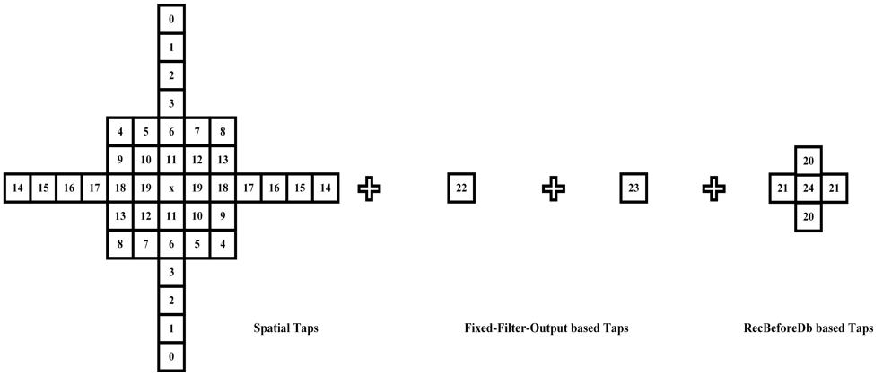
Figure 1-1 The Currently Used Filter Shape in ALF.
The fixed-filter-output based taps are introduced to provide additional information for ALF-Luma filtering. But the extra information is limited since there are only 2 fixed-filter-output based taps. In JVET-AA-0147[1], a straightforward extension of fixed-filter-output based taps is proposed to further enhance the performance of ALF.

Proposed Method
The proposed extension for ALF is shown in Figure 2-1, where spatial taps (i.e., tap #0 ~ #19) and reconstruction-before-DBF based taps (i.e., tap #26, #27, #30) are kept the same as the ECM-6.0, and more fixed-filter-output based taps (i.e., tap #20 ~ #25) are introduced into luma online-trained filters. Please note that the fixed-filter-output based taps have already been used in ECM-6.0 (i.e., tap #22 ~ #23 in Figure 1-1 and tap #28 ~ #29 in Figure 2-1). The coefficient signaling mechanism is the same as the current design in ECM and there is no filter shape switching.
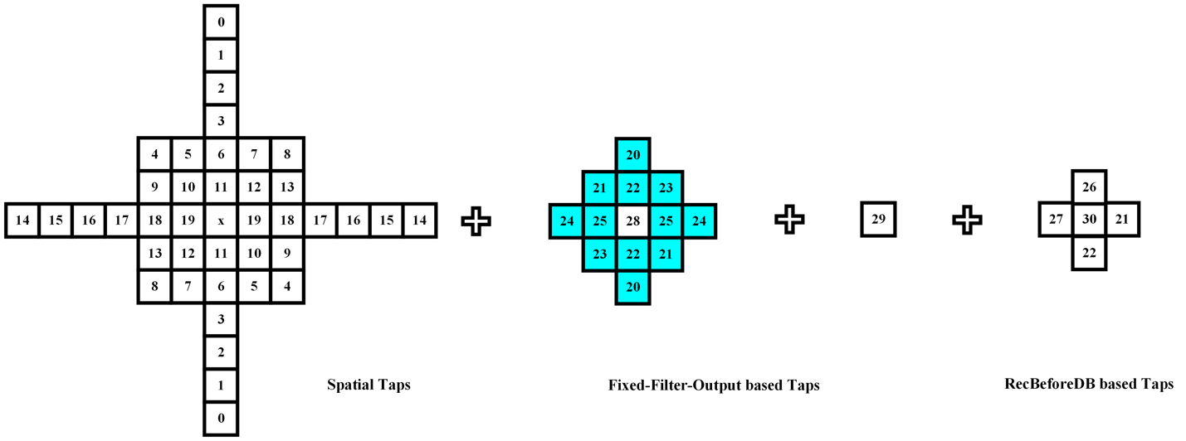
Figure 2-1 The Newly Introduced Filter Shape for ALF.

Simulation Results
The proposed method was implemented on top of the ECM-6.0 [2]. Simulations were performed following the common test conditions [3]. More detailed results could be found in the attached excel sheets. The results compared to ECM-6.0 are shown in TABLE 3-1.
TABLE 3-1 Performance of the proposed method
 | AI |  |  |  |  | RA |  |  |  |  | LB
 | Y | U | V | EncT | DecT | Y | U | V | EncT | DecT | Y | U | V | EncT | DecT
Class A1 | -0.10% | 0.00% | 0.00% | 103% | 101% | -0.08% | -0.25% | 0.07% | 101% | 101%
Class A2 | -0.11% | 0.00% | 0.00% | 101% | 102% | -0.13% | 0.07% | -0.06% | 101% | 101%
Class B | -0.07% | 0.02% | 0.02% | 101% | 102% | -0.17% | 0.16% | -0.09% | 101% | 101% | -0.24% | 0.00% | 0.09% | 102% | 101%
Class C | -0.06% | 0.01% | 0.01% | 101% | 99% | -0.15% | -0.03% | -0.01% | 101% | 101% | -0.27% | -0.56% | 0.12% | 102% | 101%
Class E | -0.14% | 0.04% | 0.04% | 102% | 101% |  |  |  |  |  | -0.09% | 0.20% | 0.11% | 105% | 101%
Overall | -0.09% | 0.02% | 0.02% | 102% | 101% | -0.14% | 0.01% | -0.03% | 101% | 101% | -0.21% | -0.14% | 0.10% | 102% | 101%
Class D | -0.04% | 0.05% | 0.05% | 102% | 99% | -0.22% | -0.15% | 0.08% | 103% | 100% | -0.31% | -0.25% | 0.39% | 104% | 101%
Class F | -0.07% | 0.03% | 0.03% | 101% | 101% | -0.04% | 0.00% | -0.08% | 104% | 100% | -0.09% | -0.47% | -0.25% | 106% | 100%

Conclusions
In this contribution, an extension of fixed-filter-output based taps for ALF is proposed. The proposed method can achieve a promising coding performance with negligible encoding time and decoding time increase. It is recommended to adopt the proposed method into ECM.

Reference
- W. Yin, K. Zhang, Z. Deng and L. Zhang, “EE2-Related: Extended Offline-Filtering Taps for ALF”, JVET-AA0147, July 2022.
- ECM-6.0, https://vcgit.hhi.fraunhofer.de/ecm/ECM/-/tree/ECM-6.0.
- M. Karczewicz, and Y. Ye, “Common test conditions and evaluation procedures for enhanced compression tool testing,” Document of Joint Video Experts Team, JVET-Y2017, by teleconference, January 2022.

Patent rights declaration(s)
Bytedance Inc. may have current or pending patent rights relating to the technology described in this contribution and, conditioned on reciprocity, is prepared to grant licenses under reasonable and non-discriminatory terms as necessary for implementation of the resulting ITU-T Recommendation | ISO/IEC International Standard (per box 2 of the ITU-T/ITU-R/ISO/IEC patent statement and licensing declaration form).

