    Joint Video Experts Team (JVET)  of ITU-T SG 16 WP 3 and ISO/IEC JTC 1/SC 29  28th Meeting, Mainz, DE, 20–28 October 2022 | Document: JVET-AB0177-v1

Title: | EE2-related: Sub-block processing for affine DMVR
Status: | Input document to JVET
Purpose: | Proposal
Author(s) or  Contact(s): | Han Huang, Yan Zhang, Zhi Zhang, Chun-Chi Chen, Vadim Seregin, Marta Karczewicz  5775 Morehouse Dr, San Diego, CA 92121 USA | Email: | hanhuang@qti.qualcomm.com  vseregin@qti.qualcomm.com
Source: | Qualcomm Inc.
_____________________________

Abstract
This contribution proposes sub-block processing for affine DMVR, where bilateral matching is performed per subblock. The refined subblock MVs and accumulated subblock bilateral matching costs are used to derive the refined control point motion vectors. The simulation result reports -0.19%, -0.14%, -0.16% Y, U, V BD-rate reduction with 100% encoder time and 101% decoder time.

Introduction
In JVET-AA0144, it is proposed to apply DMVR for the blocks coded by affine merge mode. A MV offset is added to all the control-point motion vectors to minimize the bilateral matching cost. The proposed method is tested in EE-2 Test 2.6. To calculate the bilateral matching cost for the affine coded block, subblock-based affine motion compensation is performed to generate the predictors at the two prediction directions. Then bilateral matching cost is calculated as the distortion between the two predictors.
In this contribution, the affine DMVR process is altered such that bilateral matching cost is calculated per sub-block. Then the subblock bilateral matching costs and refined subblock MVs are used to determine the overall best refined control-point motion vectors for the affine merge block.

Proposed method
The proposed method can be illustrated in Fig. 1, and summarized as the following:
- Perform integer bilateral matching is for a subset of subblocks. Accumulate the subblock bilateral matching cost to determine the best integer MV offset.
- Perform half-pel bilateral matching search using the best integer MV offset as initial offset and output a best MV offset that minimizes the bilateral matching cost for the same subset of subblocks in step 1.
- Perform linear regression using the refined subblock MVs from step 1 as input and output a set of control-point motion vectors.
- Compare the bilateral matching cost of the output of the steps 2 and 3 to select the one with the smallest cost.
Note that steps 1 and 2 are similar to that of EE-2 Test 2.6. The major difference is that only a subset of subblocks is used for bilateral matching cost calculation.

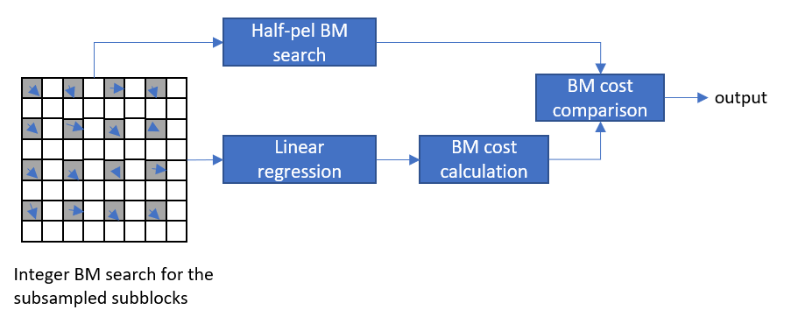
Test results
Fig. 1 Proposed method
The proposed method was implemented on top of EE-2 Test 2.6. The source code is attached in this contribution. Table 1 shows test results of proposed method, an average of -0.19%, -0.14%, -0.16% Y, U, V BD-rate reduction with 100% encoder and 101% decoder run times is reported for random access test condition. Table 2 shows test results of the proposed method without the affine linear regression, an average of -0.15%, -0.06%, -0.10% Y, U, V BD-rate reduction with 101% encoder and 101% decoder run times is reported.

Table 1 Test result of proposed method
 | Random Access Main 10
 | Over ECM-6.0
 | Y | U | V | EncT | DecT
Class A1 | -0.28% | -0.23% | -0.07% | 101% | 102%
Class A2 | -0.36% | -0.31% | -0.24% | 100% | 104%
Class B | -0.14% | -0.03% | -0.20% | 100% | 101%
Class C | -0.05% | -0.08% | -0.11% | 100% | 100%
Class E
Overall | -0.19% | -0.14% | -0.16% | 100% | 101%
Class D | -0.02% | -0.08% | -0.14% | 101% | 100%
Class F | -0.02% | -0.04% | 0.01% | 101% | 101%

Table 2 Test result of proposed method without linear regression
 | Random Access Main 10
 | Over ECM-6.0
 | Y | U | V | EncT | DecT
Class A1 | -0.23% | -0.14% | -0.02% | 101% | 103%
Class A2 | -0.31% | -0.23% | -0.21% | 101% | 103%
Class B | -0.10% | 0.07% | -0.10% | 101% | 101%
Class C | -0.02% | -0.05% | -0.10% | 100% | 101%
Class E
Overall | -0.15% | -0.06% | -0.10% | 101% | 102%
Class D | -0.01% | -0.08% | -0.11% | 100% | 100%
Class F | -0.02% | -0.02% | -0.01% | 100% | 101%

Conclusion
In this contribution, sub-block processing for affine DMVR is proposed. Comparing to ECM-6.0 anchor, an average of -0.19%, -0.14%, -0.16% Y, U, V BD-rate reduction with 100% encoder and 101% decoder run times is reported for random access test condition.

Patent rights declaration(s)
Qualcomm Incorporated may have current or pending patent rights relating to the technology described in this contribution and, conditioned on reciprocity, is prepared to grant licenses under reasonable and non-discriminatory terms as necessary for implementation of the resulting ITU-T Recommendation | ISO/IEC International Standard (per box 2 of the ITU-T/ITU-R/ISO/IEC patent statement and licensing declaration form).

References
- J. Chen, R.-L. Liao, X. Li, Y. Ye, “Non-EE2: DMVR for affine merge coded blocks”, JVET-AA0144, July 2022.

