    Joint Video Experts Team (JVET)  of ITU-T SG 16 WP 3 and ISO/IEC JTC 1/SC 29  28th Meeting, Mainz, DE, 20–28 October 2022 | Document: JVET-AB0169-v1

Title: | EE2-1.9: Self-Aware Filter Estimation for CCLM
Status: | Input document to JVET
Purpose: | Proposal
Author(s) or  Contact(s): | Kai Zhang, Li Zhang, Zhipin Deng, Tianliang Fu  8910 University Center Lane,  San Diego, CA 92122, USA | Tel:  Email: | zhangkai.video@bytedance.com  lizhang.idm@bytedance.com
Source: | Bytedance Inc.
_____________________________

Abstract
This contribution presents results of EE2-1.9, known as a self-aware filter estimation CCLM (SAFE-CCLM) method to ECM. On top of ECM-6.0, simulation results of the proposed method are reported as below:
AI: {-0.01%, 0.12%, 0.06%, 101%, 100%}; RA:{ -0.01%, 0.05%, 0.01%, 100%, 100%}
Simulation results on TGM category are reported as below:
AI: {-0.42%, -1.25%, -0.88%, 100% , 101%} RA:{ -0.09%, -0.53%, -0.37%, 100%, 99%}.

Introduction
SAFE-CCLM was proposed in JVET-AA0140 and to be studied in EE2.1.9.

Proposed methods
With SAFE-CCLM, N candidate luma down-sampling filters are predefined. As shown in Fig.1, the down-sampling filtering process for 4:2:0 color format is performed as
,
where Rec_{L}(x, y) and Rec’_{L}(x, y) are reconstructed luma samples before and after the down-sampling filtering at position (x, y), and {c₀, c₁, c₂, c₃, c₄, c₅} are filtering coefficients. It should be noted that {c₀, c₁, c₂, c₃, c₄, c₅} is set to {1, 2, 1, 1, 2, 1} in the current ECM. N candidate luma sampling filter with different coefficients are predefined by SAFE-CCLM.
Fig.2 shows a flowchart of SAFE-CCLM. First, when SAFE-CCLM is applied, a linear model between luma and chroma component is derived in the same way as that in ECM for each candidate filter. Second, prediction values are calculated with each linear model in a testing region including one-column left neighbouring samples and one-row above neighbouring samples. Third, a SAD cost between the reconstructed chroma samples and their corresponding prediction values in the testing region is computed for each filter candidate. Finally, the filter candidate with the least SAD cost is selected as the down-sampling filter to perform the CCLM prediction for the current block.
When CCLM is indicated to be used for a block, a SAFE-CCLM flag is signaled to further indicate whether SAFE-CCLM is applied.
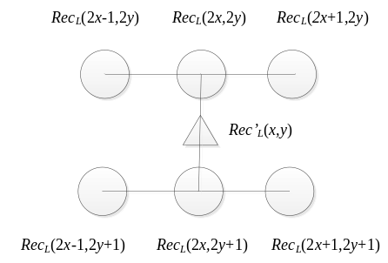
Fig. 1 Luma sample down-sampling.

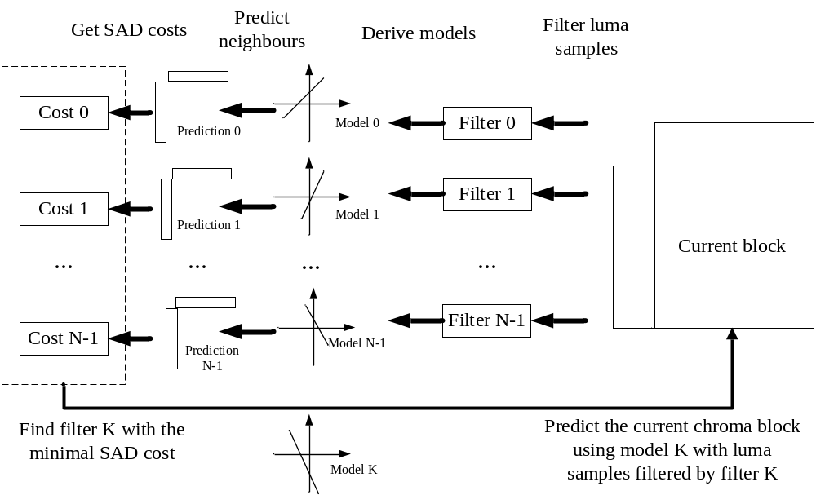
Fig. 2 A flowchart of SAFE-CCLM.
In this contribution, N = 32, and the filter candidate set is tabulated in Table 1.
Table 1: Filter candidate set when N = 32
F0 | F1 | F2 | F3 | F4 | F5 | F6 | F7
$$\frac{1}{4}\left[\begin{matrix}0 & 1 & 1 \\ 0 & 1 & 1\end{matrix}\right]$$ | $$\frac{1}{2}\left[\begin{matrix}0 & 1 & 1 \\ 0 & 0 & 0\end{matrix}\right]$$ | $$\frac{1}{2}\left[\begin{matrix}0 & 0 & 1 \\ 0 & 0 & 1\end{matrix}\right]$$ | $$\frac{1}{2}\left[\begin{matrix}0 & 0 & 0 \\ 0 & 1 & 1\end{matrix}\right]$$ | $$\frac{1}{2}\left[\begin{matrix}0 & 1 & -1 \\ 0 & 1 & -1\end{matrix}\right]$$ | $$\frac{1}{4}\left[\begin{matrix}1 & 2 & 1 \\ -1 & -2 & -1\end{matrix}\right]$$ | $$\frac{1}{2}\left[\begin{matrix}0 & 1 & 0 \\ 0 & -1 & 0\end{matrix}\right]$$ | $$\frac{1}{2}\left[\begin{matrix}0 & 0 & 1 \\ 0 & 0 & -1\end{matrix}\right]$$
F8 | F9 | F10 | F11 | F12 | F13 | F14 | F15
$$\left[\begin{matrix}0 & 1 & 0 \\ 0 & 0 & 0\end{matrix}\right]$$ | $$\left[\begin{matrix}0 & 0 & 1 \\ 0 & 0 & 0\end{matrix}\right]$$ | $$\left[\begin{matrix}0 & 0 & 0 \\ 0 & 1 & 0\end{matrix}\right]$$ | $$\left[\begin{matrix}0 & 0 & 0 \\ 0 & 0 & 1\end{matrix}\right]$$ | $$\left[\begin{matrix}1 & 0 & 0 \\ 0 & 0 & 0\end{matrix}\right]$$ | $$\left[\begin{matrix}0 & 0 & 0 \\ 1 & 0 & 0\end{matrix}\right]$$ | $$\frac{1}{4}\left[\begin{matrix}1 & 2 & 1 \\ 0 & 0 & 0\end{matrix}\right]$$ | $$\frac{1}{4}\left[\begin{matrix}0 & 0 & 0 \\ 1 & 2 & 1\end{matrix}\right]$$
F16 | F17 | F18 | F19 | F20 | F21 | F22 | F23
$$\frac{1}{2}\left[\begin{matrix}-1 & 1 & 0 \\ -1 & 1 & 0\end{matrix}\right]$$ | $$\frac{1}{2}\left[\begin{matrix}-1 & 0 & 1 \\ -1 & 0 & 1\end{matrix}\right]$$ | $$\frac{1}{2}\left[\begin{matrix}0 & 1 & -1 \\ 0 & 1 & -1\end{matrix}\right]$$ | $$\frac{1}{4}\left[\begin{matrix}3 & 6 & 3 \\ -1 & -2 & -1\end{matrix}\right]$$ | $$\frac{1}{2}\left[\begin{matrix}0 & 1 & 0 \\ 0 & 0 & -1\end{matrix}\right]$$ | $$\frac{1}{2}\left[\begin{matrix}0 & 0 & 1 \\ 0 & -1 & 0\end{matrix}\right]$$ | $$\frac{1}{2}\left[\begin{matrix}0 & 1 & 0 \\ -1 & 0 & 0\end{matrix}\right]$$ | $$\frac{1}{2}\left[\begin{matrix}1 & 0 & 0 \\ 0 & -1 & 0\end{matrix}\right]$$
F24 | F25 | F26 | F27 | F28 | F29 | F30 | F31
$$\left[\begin{matrix}-1 & 2 & -1 \\ -1 & 2 & -1\end{matrix}\right]$$ | $$\left[\begin{matrix}0 & 0 & 1 \\ -1 & 0 & 0\end{matrix}\right]$$ | $$\left[\begin{matrix}1 & 0 & 0 \\ 0 & 0 & -1\end{matrix}\right]$$ | $\frac{1}{4}$ $\left[\begin{matrix}1 & 0 & 1 \\ 1 & 0 & 1\end{matrix}\right]$ | $$\left[\begin{matrix}1 & 1 & 0 \\ 1 & -1 & 0\end{matrix}\right]$$ | $$\left[\begin{matrix}0 & 1 & 1 \\ 0 & -1 & 1\end{matrix}\right]$$ | $$\left[\begin{matrix}1 & 0 & 1 \\ 0 & 1 & 0\end{matrix}\right]$$ | $$\left[\begin{matrix}0 & 1 & 0 \\ 1 & 0 & 1\end{matrix}\right]$$

Experimental results
The proposed method is implemented on top of ECM-6.0 [1] and tested following the common test conditions [2]. The simulation results are summarized in Table 2.
Table 2: Coding performance
 | AI |  |  |  |  | RA
 | Y | U | V | EncT | DecT | Y | U | V | EncT | DecT
Class A1 | -0.01% | 0.13% | 0.11% | 102% | 100% | 0.00% | 0.05% | 0.19% | 101% | 100%
Class A2 | -0.06% | 0.10% | -0.28% | 103% | 103% | -0.05% | -0.06% | -0.17% | 100% | 101%
Class B | -0.01% | 0.21% | 0.27% | 101% | 101% | -0.01% | 0.15% | -0.12% | 101% | 100%
Class C | 0.02% | 0.17% | 0.21% | 101% | 99% | 0.01% | 0.01% | 0.16% | 98% | 99%
Class E | 0.02% | -0.07% | -0.19% | 101% | 99%
Overall | -0.01% | 0.12% | 0.06% | 101% | 100% | -0.01% | 0.05% | 0.01% | 100% | 100%
Class D | 0.04% | 0.04% | 0.01% | 100% | 97% | 0.06% | 0.20% | -0.24% | 100% | 100%
Class F | -0.22% | -0.83% | -0.75% | 99% | 100% | -0.17% | -0.68% | -0.34% | 99% | 100%
Class TGM | -0.42% | -1.25% | -0.88% | 100% | 101% | -0.09% | -0.53% | -0.37% | 100% | 99%

Conclusions
This contribution presents a method of SAFE-CCLM. The proposed method contributes promising coding gains with acceptable computational complexity. Considering the acceptable trade-off between coding performance and complexity especially on SCC sequences, it is recommended to adopt SAFE-CCLM into ECM for SCC testing.

References
- ECM-6.0, https://vcgit.hhi.fraunhofer.de/ecm/ECM/-/tree/ECM-6.0.
- M. Karczewicz, Y. Ye, “Common Test Conditions and evaluation procedures for enhanced compression tool testing”, JVET-Y2017, Jan. 2022.

Patent rights declaration(s)
Bytedance Inc. may have current or pending patent rights relating to the technology described in this contribution and, conditioned on reciprocity, is prepared to grant licenses under reasonable and non-discriminatory terms as necessary for implementation of the resulting ITU-T Recommendation | ISO/IEC International Standard (per box 2 of the ITU-T/ITU-R/ISO/IEC patent statement and licensing declaration form).

