    Joint Video Experts Team (JVET)  of ITU-T SG 16 WP 3 and ISO/IEC JTC 1/SC 29  28th Meeting, Mainz, DE, 20–28 October 2022 | Document: JVET-AB0145-v2

Title: | EE2-2.6-related: On Decoder-side Affine Model Refinement (DAMR)
Status: | Input document to JVET
Purpose: | Proposal
Author(s) or  Contact(s): | Jie Chen  Ru-Ling Liao  Xinwei Li  Yan Ye | Tel:  Email: | jiechen.cj@alibaba-inc.com
Source: | Alibaba Group.
_____________________________

Abstract
This contribution proposes to refine the affine model for affine merge coded blocks in decoder sider without additional signaling. In the proposed method, both the base MV and non-translation parameters of affine model are refined to improve the accuracy of the affine model inherited from the previously coded blocks in merge mode. It is reported that on top of ECM-6.0, by applying the proposed method, it achieves {-0.26%(Y), -0.16%(U), -0.19%(V)} coding gain in RA on average with luma coding gain reaching -0.36% on class A1 and -0.50% on classA2.

Problem statement
Decoder-side Motion Vector Refinement (DMVR) is a coding tool to improve the MV accuracy inherited from the spatial or temporal neighbors in merge mode without additional signaling. In ECM[1], a multi-pass decoder-side motion vector refinement is applied. In the first pass, bilateral matching (BM) is applied to the coding block. In the second pass, BM is applied to each 16x16 subblock within the coding block. In the third pass, MV in each 8x8 subblock is refined by applying bi-directional optical flow (BDOF). The refined MVs are stored for both spatial and temporal motion vector prediction. The DMVR aims at refining the motion vector inherited from the previously coded blocks in merge mode as the inherited motion information may not be perfectly fit for the current block.
However, conventional DMVR can only be applied on the translation motion coded blocks. For affine motion coded blocks, the inherited affine model in merge mode may also be not well matched with the current block. Thus, JVET-AA0144[2] tried to extend DMVR to affine motion coded blocks and was tested as EE2-2.6[3]. However, in EE2-2.6, only base MV of the affine model is refined. The non-translation parameters such as rotation and scaling are not refined.
To solve the problem, a decoder-side affine model refinement (DAMR) is proposed in which both the base MV and the non-translation parameters of the affine mode are refined.

Proposed method

Affine model
Generally, affine model can be described using the following equations
$\left\{\begin{aligned}{mv}_{x}=a(x-x_{0})+b(y-y_{0})+{mv}_{0x} \\ {mv}_{y}=c(x-x_{0})+d(y-y_{0})+{mv}_{0y}\end{aligned}\right.$ (1)
wherein$({mv}_{x},{mv}_{y})$ is the motion vector at any location $(x,y)$. ${(mv}_{0x}, {mv}_{0y})$ is the motion vector at location ($x_{0}, y_{0})$ which is called base MV of the affine model. Theoretically, motion vector at any location on the plane can be used as the base MV. $a$, $b$, $c$ and $d$ are the non-translation parameters which defines rotation, scaling and other non-translation motion of the affine model. Non-translation parameters $a$, $b$, $c$ and $d$ can be derived from motion vectors at any other two locations than ($x_{0}, y_{0})$. Suppose $({mv}_{1x},{mv}_{1y})$ and $({mv}_{2x},{mv}_{2y})$ are motion vectors at location ($x_{1}, y_{1})$ and ($x_{2}, y_{2})$, then $a$, $b$, $c$ and $d$ can be derived as
$\left\{\begin{aligned}a=\frac{mv_{1x}-mv_{0x}}{x_{1}-x_{0}} \\ b=\frac{{mv}_{0y}-mv_{1y}}{y_{1}-y_{0}} \\ c=\frac{{mv}_{1y}-{mv}_{0y}}{Wx_{1}-x_{0}} \\ d=\frac{{mv}_{1x}-{mv}_{0x}}{y_{1}-y_{0}}\end{aligned}\right.$ (2)
In the equation (1), there are totally six parameters including 4 non-translation parameters and base MV. Thus, it is called 6-parameter affine model. In ECM, besides 6-parameter affine model, there are also 4-parameter affine mode as described in (3).
$\left\{\begin{aligned}{mv}_{x}=a(x-x_{0})+b(y-y_{0})+{mv}_{0x} \\ {mv}_{y}=b\left(x-x_{0}\right)-a(y-y_{0})+{mv}_{0y}\end{aligned}\right.$ (3)

Affine model refinement
In this contribution, it is proposed to refine all the parameters of the affine model to improve the accuracy of the model inherited from the neighboring blocks. The refinement is divided into two steps. In the first step, only the base MV is refined and the non-translation parameters are kept. The first step is the same as EE2-2.6, more details can found be found in JVET-AB0112.
In the second step, based on the affine model refined in the first step, the non-translation parameters are refined. The search process has three stages. In the first stage as shown in Figure 1(a), the top-left CPMV is fixed as base MV of the affine model and the parameters $a$, $b$, $c$ and $d$ are jointly searched with a cross pattern to find best values by minimizing the cost of bilateral matching. Then CPMVs are recalculated with the refined parameter values of $a$, $b$, $c$ and $d$. In the second stage as shown in Figure 1(b), the new top-right CPMV is fixed as the base MV and the parameters $a$, $b$, $c$ and $d$ are jointly searched again to find new best values, and CPMVs are recalculated again after search. In the third stage as shown in Figure 1(c), the new left-bottom CPMV is fixed as the base MV and the same search process is applied on parameters $a$, $b$, $c$ and $d$ once again to get the final refined model. For 4-parameter affine model, only parameters $a$ and $b$ need to be refined and the search process itself is the same as that for 6-parameter affine model. For each search point in the search process, motion compensation is applied for the whole CU and the SAD between two predictors of the CU are used as the cost.
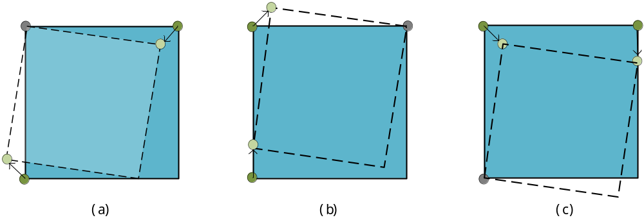
Figure 1 Three stages of non-translation parameters search

Simulation results

Coding performance
The proposed method is implemented on top of ECM6.0. The performance is evaluated based on ECM common test conditions in JVET-Y2017[4].

Table 1: Results of RA
 | Random Access Main 10
 | Over ECM-6.0
 | Y | U | V | EncT | DecT
Class A1 | -0.36% | -0.25% | -0.19% | 121% | 118%
Class A2 | -0.50% | -0.38% | -0.35% | 117% | 121%
Class B | -0.18% | -0.03% | -0.17% | 109% | 109%
Class C | -0.09% | -0.08% | -0.09% | 104% | 103%
Class E
Overall | -0.26% | -0.16% | -0.19% | 112% | 111%
Class D | -0.11% | -0.18% | -0.10% | 102% | 102%
Class F | -0.04% | 0.00% | -0.07% | 105% | 104%

Conclusion
This contribution proposed to refine both base MV and non-translation parameters of affine model for affine merge coded blocks. The base MV refinement process is the same as EE2-2.6. And on top of EE2-2.6, the non-translation parameters are also refined in this contribution. Experimental results showed that the proposed method achieves {-0.26%, -0.16%, -0.19%} coding gain with 112%/111% encoding/decoding time on average, with higher coding gain for 4K sequences. Even compared with EE2-2.6, it still has -0.11% additional averaged coding gain and higher 4K sequences coding gain. Thus, it is suggested to study non-translation parameters refinement in the next round of EE.

References
- M. Coban, F. Le Léannec, K. Naser, J. Ström, L. Zhang, “Algorithm description of Enhanced Compression Model 6 (ECM 6)”, JVET-AA2025, July. 2022
- J. Chen, R. -L. Liao, X. Li, Yan. Ye, “Non-EE2: DMVR for affine merge coded blocks”, JVET-AA0144, July. 2022
- J. Chen, R. -L. Liao, X. Li, Yan. Ye, “EE2-2.6: DMVR for affine merge coded blocks”, JVET-AB00112, Oct. 2022
- M. Karczewice, Y. Yan, “Common Test Conditions and evaluation procedures for enhanced compression tool testing”, JVET-Y2017, Jan. 2022

Patent rights declaration(s)
Alibaba Group may have current or pending patent rights relating to the technology described in this contribution and, conditioned on reciprocity, is prepared to grant licenses under reasonable and non-discriminatory terms as necessary for implementation of the resulting ITU-T Recommendation | ISO/IEC International Standard (per box 2 of the ITU-T/ITU-R/ISO/IEC patent statement and licensing declaration form).

