    Joint Video Experts Team (JVET)  of ITU-T SG 16 WP 3 and ISO/IEC JTC 1/SC 29  28th Meeting, Mainz, DE, 20–28 October 2022 | Document: JVET-AB0141-v0

Title: | EE1-related: QP-based loss function design for NN-based in-loop filter
Status: | Input document to JVET
Purpose: | Proposal
Author(s) or  Contact(s): | Chuan Zhou  Zhuoyi Lv  Jinrong Zhang (vivo)  Wei Chen  Jiangyuan Guo  Bo Ai (BJTU) | Email: | chuan.zhou@vivo.com  zhuoyi.lv@vivo.com
Source: | vivo Mobile Communication Co., Ltd, Beijing Jiaotong University
_____________________________

Abstract
In this contribution, a new loss function is defined where quantization parameter is used as a factor for the loss calculation in the training stage. In this study, the intra models from NCS-1.0 with NN filter set 1 are retrained using the latest published scripts. BD-rate changes of {Y, Cb, Cr} are summarized as follows:
- Compared with NNVC2.0
AI: { -7.22 %, -20.64 %, -21.34 % }
- Compared with NCS-1.0 with the retrained intra model
AI: { -0.12%, -0.69%, -1.05 % }

Introduction
In NN-based in-loop filter, the commonly used loss functions, L1 and L2 have not considered the information related to video coding.
$$MAE\left(x,y\right)= \frac{\sum_{i=1}^{n}{|y_{i}-{f(x}_{i})|}}{n}$$
$$MSE\left(x,y\right)= \frac{\sum_{i=1}^{n}{{(y_{i}-{f(x}_{i}))}^{2}}}{n}$$

Proposed method
Since the training samples with different quantization parameters have different training difficulties, the new designed loss function can be formulated as follows:
$Loss= w* MAE\left(x,y\right)$ or
$$Loss= w* MSE\left(x,y\right)$$
$$w= 1- \frac{1}{1+\exp\left(30-qp\right)/6}$$
where $w$ denotes the weight assigned to the conventional loss function according to the quantization parameters. The following figure shows the function curve of $w(qp)$.
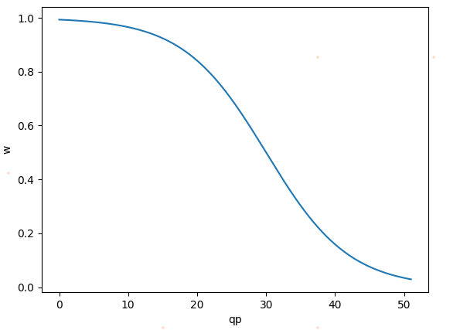

Training information
The scripts, which are available in NCS-1.0/training, were used in the training procedure. More specifically, except for the scaling value of quantization parameter is 64, the scaling value of other training data is 1024. All models were trained for 50 epochs. The proposed loss function only covers the first 30 epochs. For luma model and chroma model, the training takes about 30 and 15 hours respectively. The models are converted with SADL using floating point-based calculation for testing.

Experimental results
The proposed method was tested on top of NCS-1.0 under the common test conditions [2].
  - Results over NNVC-2.0
 | All intra
 | Y-PSNR | U-PSNR | V-PSNR | EncT | DecT
Class A1 | -6.34% | -17.86% | -19.40% | 234% | 67771%
Class A2 | -6.42% | -20.88% | -19.70% | #DIV/0! | #DIV/0!
Class B | -6.41% | -22.07% | -22.22% | 165% | 52319%
Class C | -7.53% | -19.96% | -22.71% | 137% | 35265%
Class E | -9.84% | -21.72% | -21.61% | 168% | 59340%
Overall | -7.22% | -20.64% | -21.34% | #DIV/0! | #DIV/0!
Class D | -7.52% | -20.53% | -22.59% | 117% | 27111%
Class F | -3.86% | -13.22% | -12.40% | 127% | 32551%

  - Results over NCS-1.0 filter set 1 with the retrained intra models
In order to avoid the performance error caused by training, the intra model was retrained in the same way except for different loss functions.
 | All intra
 | Y-PSNR | U-PSNR | V-PSNR | EncT | DecT
Class A1 | 0.02% | -0.04% | -0.70% | 100% | 100%
Class A2 | -0.04% | -0.36% | -1.65% | 100% | 100%
Class B | -0.07% | -0.68% | -1.00% | 100% | 98%
Class C | -0.28% | -1.02% | -1.06% | 99% | 98%
Class E | -0.21% | -1.23% | -0.87% | 97% | 98%
Overall | -0.12% | -0.69% | -1.05% | 99% | 99%
Class D | -0.32% | -1.16% | -1.59% | 90% | 94%
Class F | 0.02% | -0.84% | -0.07% | 96% | 89%

Conclusion
This contribution proposes a new loss function, which can achieve coding gain by introducing quantization parameters into the loss function calculation. It is suggested to further study this method in EE1.

References
- F. Galpin, T. Dumas, P. Bordes, E. François, ”AHG11: Small Ad-hoc Deep-Learning Library (SADL) update”, JVET-AA0086, Joint Video Experts Team (JVET) of ITU-T SG 16 WP 3 and ISO/IEC JTC 1/SC 29, 27th Meeting, by teleconference, July 2022.
- Common Test Conditions and evaluation procedures for neural network-based video coding technology, E. Alshina, R.-L. Liao, S. Liu, A. Segall, JVET-AA2016, July 2022.

Patent rights declaration(s)
vivo Mobile Communication Co., Ltd. may have current or pending patent rights relating to the technology described in this contribution and, conditioned on reciprocity, is prepared to grant licenses under reasonable and non-discriminatory terms as necessary for implementation of the resulting ITU-T Recommendation | ISO/IEC International Standard (per box 2 of the ITU-T/ITU-R/ISO/IEC patent statement and licensing declaration form).

