    Joint Video Experts Team (JVET)  of ITU-T SG 16 WP 3 and ISO/IEC JTC 1/SC 29  28th Meeting, Mainz, DE, 20–28 October 2022 | Document: JVET-AB0103_v2

Title: | EE2-1.16 related : Modifications of picture-level geometry transform
Status: | Input document to JVET
Purpose: | Proposal
Author(s) or  Contact(s): | Jangwon Choi  Sunmi Yoo  Jaehyun Lim  Seung Hwan Kim*  19 Yangjadaero-11gil  Seocho-gu, Seoul 06772  South Korea  10680 Treena St, San Diego, CA 92131, USA* | Tel:  Email: | +82-2-6912-6477  jangwon84.choi@lge.com
Source: | LG Electronics Inc.
_____________________________

Abstract
This contribution introduces two methods based on picture-level geometry transform. Both methods allow only vertical flip geometry transform. In Method 1, a flag is signalled to indicate if the vertical flip geometry transform is applied or not after comparing RD costs in the encoder side. In Method 2, a picture-level edge feature analysis is applied based on the edge types of pixels to determine if the vertical flip of geometry transform is applied or not. Hence, the RD comparing process required in Method 1 is not necessary in Method 2.
The experimental results of the proposed methods are shown below:
- Method 1 (only vertical flip geometry transform is considered)
  - AI: -0.20% / -0.31% / -0.34% for Y/U/V with 100%/98% enc/dec complexity
  - RA: X.XX% / X.XX% / X.XX% for Y/U/V with XX%/ XX % enc/dec complexity
- Method 2 (the edge feature based geometry transform selection method on top of Method 1)
  - AI: -0.17% / -0.29% / -0.36% for Y/U/V with 100%/97% enc/dec complexity
  - RA: X.XX% / X.XX% / X.XX% for Y/U/V with XX%/ XX % enc/dec complexity

Introduction
In the last meeting, a method of picture-level geometry transform was proposed and decided to be investigated in EE [1]. In this proposal, three kinds of geometry transform: horizontal flip, vertical flip and 180°-rotation can be applied at picture level. The information of transform is signaled in the slice header to indicate whether a geometry transform is applied, and which transform is applied. To decide the type of geometry transform, the encoder tries to encode the picture with each geometry transform as well as non-transform case and selects the one with the minimum RD cost.

Proposed method
In the proposed Method 1, the vertical flip is only used for the picture level geometry transform. Hence, one bit flag is signalled to indicate if the vertical flip is applied or not, and the number of RD comparing process is also reduced in the encoding stage compared to EE [1].
On top of Method 1, Method 2 applies the edge feature based geometry transform selection method which is replacing the RD comparing process in Method 1 as below. Hence, it alsoreduces the encoder pre-processing complexity of picture-level geometry transform.

- For the picture-level edge feature analysis, Robinson edge detection filters [2] are applied in all pixels of picture, and decide the edge type of each pixel which is one of 8 directions (E, NE, N, NW, W, SW, S, SE, as shown in Figure 1).
- Calculate the number of pixels of each edge directions, $n_{E}, n_{NE},n_{N}, n_{NW}, n_{W}, n_{SW}, n_{S}$ and $n_{SE}$
- If $n_{NE}+n_{SW}≤ n_{NW}+n_{SE}$, the vertical flip of geometry transform is applied in the corresponding picture.

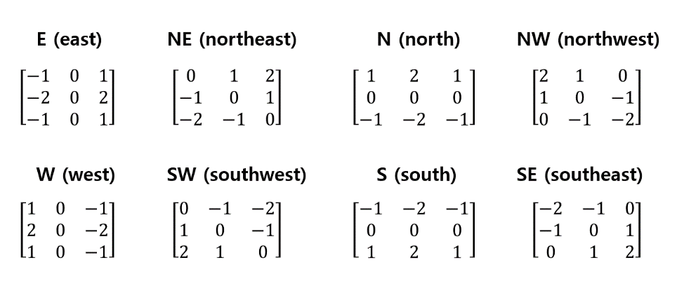
Figure 1. 8 edge detection filter in Robinson method.

In Method 2, the size restriction of picture height in EE2-1.16 which is enabling the geometry transform over 720 is also removed.

Experimental results
The proposed methods are implemented on top of ECM-6.0[3] and the simulations are tested under ECM test condition with all intra and random access configurations [4].
In Table 1, the experimental results of Method 1 (only vertical flip geometry transform is considered) is presented. The simulation results for Method 2 (the edge feature based geometry transform selection method on top of Method 1) is shown in Table 2.

Table 1 The experimental results for method 1
 | All Intra Main 10
 | Over ECM-6.0
 | Y | U | V | EncT | DecT
Class A1 | -0.23% | -0.29% | -0.25% | 101% | 98%
Class A2 | -0.48% | -0.32% | -0.31% | 101% | 98%
Class B | -0.29% | -0.75% | -0.89% | 100% | 97%
Class C | 0.00% | 0.00% | 0.00% | 101% | 100%
Class E | 0.00% | 0.00% | 0.00% | 100% | 98%
Overall | -0.20% | -0.31% | -0.34% | 100% | 98%
Class D | 0.00% | 0.00% | 0.00% | 101% | 101%
Class F | -0.06% | -0.10% | 0.03% | 102% | 97%
Class TGM | -0.63% | -0.47% | -0.52% | 110% | 101%
 | Random Access Main 10
 | Over ECM-6.0
 | Y | U | V | EncT | DecT
Class A1 | #VALUE! | #VALUE! | #VALUE! | #NUM! | #NUM!
Class A2 | #VALUE! | #VALUE! | #VALUE! | #NUM! | #NUM!
Class B | #VALUE! | #VALUE! | #VALUE! | #NUM! | #NUM!
Class C | 0.00% | 0.00% | 0.00% | 99% | 98%
Class E
Overall | #VALUE! | #VALUE! | #VALUE! | #NUM! | #NUM!
Class D | 0.00% | 0.00% | 0.00% | 99% | 98%
Class F | #VALUE! | #VALUE! | #VALUE! | #NUM! | #NUM!
Class TGM | #VALUE! | #VALUE! | #VALUE! | #NUM! | #NUM!

Table 2 The experimental results for method 2
 | All Intra Main 10
 | Over ECM-6.0
 | Y | U | V | EncT | DecT
Class A1 | -0.25% | -0.31% | -0.29% | 99% | 97%
Class A2 | -0.25% | -0.28% | -0.27% | 100% | 98%
Class B | -0.32% | -0.73% | -0.95% | 99% | 97%
Class C | -0.01% | 0.02% | -0.03% | 100% | 98%
Class E | 0.01% | 0.04% | 0.02% | 100% | 97%
Overall | -0.17% | -0.29% | -0.36% | 100% | 97%
Class D | -0.05% | -0.18% | -0.16% | 100% | 102%
Class F | -0.11% | -0.21% | 0.07% | 100% | 96%
Class TGM | -0.55% | -0.40% | -0.48% | 102% | 102%
 | Random Access Main 10
 | Over ECM-6.0
 | Y | U | V | EncT | DecT
Class A1 | #VALUE! | #VALUE! | #VALUE! | #NUM! | #NUM!
Class A2 | #VALUE! | #VALUE! | #VALUE! | #NUM! | #NUM!
Class B | #VALUE! | #VALUE! | #VALUE! | #NUM! | #NUM!
Class C | 0.00% | -0.04% | 0.08% | 98% | 97%
Class E
Overall | #VALUE! | #VALUE! | #VALUE! | #NUM! | #NUM!
Class D | 0.03% | 0.04% | -0.33% | 99% | 97%
Class F | #VALUE! | #VALUE! | #VALUE! | #NUM! | #NUM!
Class TGM | #VALUE! | #VALUE! | #VALUE! | #NUM! | #NUM!

References
- W. Jia, K. Zhang, Y. Wang, T. Fu, Y. Li, and L. Zhang, “AHG12/Non-EE2: Picture-Level Geometry Transform”, JVET-AA0142, July. 2022.
- Muthukrishnan.R and M. Radha, “edge detection techniques for image segmentation”, International Journal of Computer Science and Information Technologies, Vol 3, No 6, Dec 2011.
- ECM-6.0, https://vcgit.hhi.fraunhofer.de/ecm/ECM.
- M. Karczewicz and Y. Ye, “Common Test Conditions and evaluation procedures for enhanced compression tool testing”, JVET-Y2017, Feb. 2022.

Patent rights declaration(s)
LG Electronics Inc. may have current or pending patent rights relating to the technology described in this contribution and, conditioned on reciprocity, is prepared to grant licenses under reasonable and non-discriminatory terms as necessary for implementation of the resulting ITU-T Recommendation | ISO/IEC International Standard (per box 2 of the ITU-T/ITU-R/ISO/IEC patent statement and licensing declaration form).

