    Joint Video Experts Team (JVET)  of ITU-T SG 16 WP 3 and ISO/IEC JTC 1/SC 29  28th Meeting, Mainz, DE, 20–28 October 2022 | Document: JVET-AB0100-v2

Title: | Non-EE2: Separable KLT for intra coding
Status: | Input document to JVET
Purpose: | Proposal
Author(s) or  Contact(s): | Moonmo Koo  Jaehyun Lim  19 Yangjaedaero-11gil  Seocho-gu, Seoul 06772  South Korea  Jie Zhao  Seung-Hwan Kim  10680 Treena St. St# 550  San Diego, CA 92131, USA | Tel:  Email: | +1-858-635-5226  moonmo.koo@lge.com  jaehyun.lim@lge.com  jie.zhao@lge.com  seunghwan3.kim@lge.com
Source: | LG Electronics Inc.
_____________________________

Abstract
In this contribution, KLT kernels of length 8, 16, and 32 are proposed, which can be applied as separable primary transforms on top of adaptive MTS. These KLTs are commonly applied to every block shape of which width and height ranges from 4 to 32 for only intra-coded CU. And, since they can also be applied to only one direction with DCT-2 coupled in the other, up to three pairs can be candidates as follows: (KLT, KLT), (KLT, DCT-2), and (DCT-2, KLT). These pairs are activated by setting a newly employed flag and also an additional index is followed to indicate one of the pairs. The experimental results for the proposed KLTs are reportedly observed that the BD-rates are reduced by 0.10% with 113%/100% encoding/decoding time changes for AI.

Proposed architecture
The proposed KLTs consists of three kernels for length 8, 16, and 32 each of which matrix dimension is 8x8, 16x16, and 32x32, respectively. These kernels are applied to all kinds of block shapes which has width and height ranges from 4 to 32 except 4x4 block because there is not a KLT kernel for length 4. For 4xN or Nx4 blocks with N greater than 4, the proposed kernels are applied to only one segment of length 8, 16, or 32, together with DCT-2 of length 4 for the other segment. Moreover, when absolute sum of transform coefficients is less than or equal to 6, the KLTs are disabled without any signalling where only adaptive MTS is allowed.
The memory usage of the proposed KLTs accounts to be 1,344 bytes, i.e. (8x8+16x16+32x32) kernel coefficients and 1 byte for each coefficient. Considering the fact that the existing adaptive MTS employs five types of trigonometric transforms (DCT-8, DST-7, DCT-5, DST-4, and DST-1, excluding IDT) and each has kernels for 4, 8, 16, and 32, the memory footprint for the proposed kernels is more than five times less than that for adaptive MTS.
A flag for indicating whether the proposed KLTs are applied or not is parsed, only when the existing MTS flag is parsed as 1. If the flag is equal to 1, signalling of an index consisting of two bins is followed in order to indicate a transform pair among the three candidates, i.e. (KLT, KLT), (KLT, DCT-2) and (DCT-2, KLT). Otherwise, ordinary adaptive MTS signalling is accompanied. For 4xN or Nx4 blocks with N greater than 4, the index need not to be signalled, because it is automatically decided which of (KLT, DCT-2) or (DCT-2, KLT) is to be applied according to the block shape. The first and second bins comprising of the index indicates whether or not the KLT is applied to both directions and which direction the KLT is applied to, respectively, and the second bin is signalled only if the first bin is equal to 1. Both bins are context-coded.

Experimental results
The proposed architectures have been implemented based on ECM-6.0 reference software according to common test conditions defined in JVET-Y2017 [1].
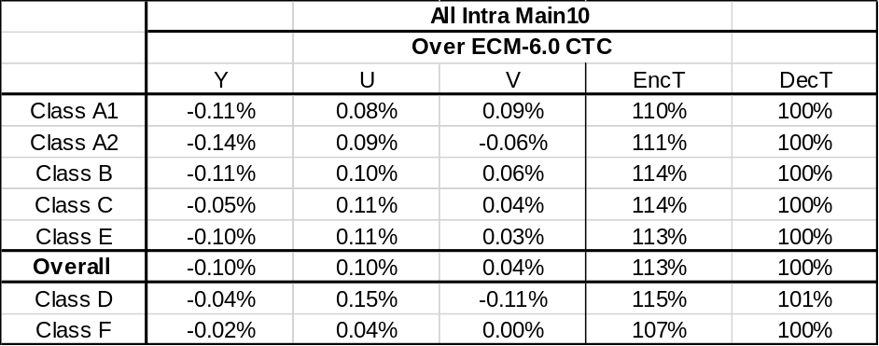

Conclusion
In this contribution, separable KLTs for lengths of 8, 16, and 32 for primary transform are proposed. The existing adaptive MTS is untouched, and the new KLTs on top of the current primary transform structure show additional coding performance improvement. Therefore, it is recommended to further investigate the benefits of the proposed KLTs in next EE2.

References
- M. Karczewicz and Y. Ye, “Common test conditions and evaluation procedures for enhanced compression tool testing”, JVET-Y2017, 25th Meeting, by teleconference, 12–21 January 2022.

Patent rights declaration(s)
LG Electronics Inc. may have current or pending patent rights relating to the technology described in this contribution and, conditioned on reciprocity, is prepared to grant licenses under reasonable and non-discriminatory terms as necessary for implementation of the resulting ITU-T Recommendation | ISO/IEC International Standard (per box 2 of the ITU-T/ITU-R/ISO/IEC patent statement and licensing declaration form).

