    Joint Video Experts Team (JVET)  of ITU-T SG 16 WP 3 and ISO/IEC JTC 1/SC 29  28th Meeting, Mainz, DE, 20–28 October 2022 | Document: JVET-AB0085-v2

Title: | AHG5: On conformance test of multilayer coding
Status: | Input document to JVET
Purpose: | Proposal
Author(s) or  Contact(s): | S. Iwamura  S. Nemoto  A. Ichigaya | Tel:  Email: | iwamura.s-gc@nhk.or.jp
Source: | NHK
_____________________________

Abstract
This contribution proposes addition of new conformance tests of multiple profile/tier/level (PTL) support in multilayer coding. In VVC specifications, when the number of layers to be encoded is greater than 1, multiple PTLs can be signalled in VPS. For each PTL, profile, tier and general constraints information is optionally signalled based on vps_pt_present_flag. However, the current implementation of VTM-18.0 only allows one profile, tier, and general constraints information to be signalled in the VPS. Due to this limitation, VTM-18.0 does not work properly in the case of multiple PTL signalling for different OLSs such as applying Main 10 profile to the base layer and Multilayer Main 10 profile to the enhancement layer.
A patch file for the software fix is provided in the contribution. Note that this fix only affects VTM software and VVC specification is not changed.
In addition to the software fix, addition of two new conformance tests is proposed for the following use cases:
- Different profiles applying to different OLSs
- The same profile applying to multiple independent layers
The sample bitstreams of the proposed conformance tests are also provided in this contribution.

Problem statement and proposed SW changes
In VVC, it is allowed to signal multiple profile, tier, and level information (PLTs) when the number of layers is greater than 1. In PLT, some information including level information and multilayer enabled flag is always signalled whereas profile, tier, and general constraints information are optionally signalled.
In multilayer coding, different profiles applying to different output layer sets (OLSs) might be necessary for backward compatibility and extensibility for broadcasting and streaming applications. For example, when some service providers may want to start their initial services with HD resolution using Main 10 profile, the first-generation decoder may only support Main 10 profile. If the service providers then want to provide higher resolution (4K) service, a possible way to keep backward compatibility is to use multi layer coding. In such use case, 2K content is coded as base layer and 4K content is coded as enhancement layer. OLS0 includes only base layer and applied profile should be Main 10 profile for backward compatibility and OLS1 includes base and enhancement layers and applied profile should be Multilayer Main 10 profile.

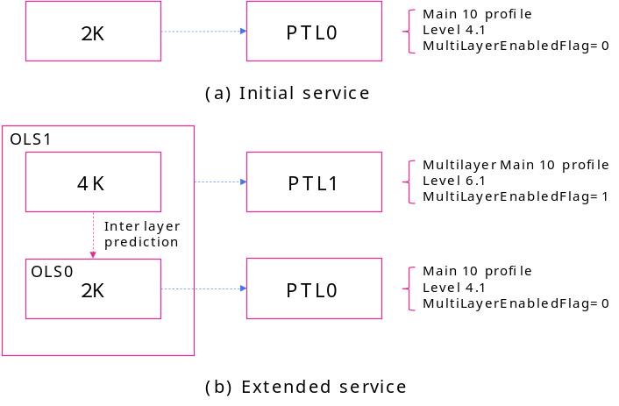
Figure 1. Service using multilayer coding

However, in the current implementation of VTM-18.0, multiple PTL signalling is allowed but the abovementioned optional information is allowed to be signalled only in the first PLT. Because of this limitation, even if multiple OLSs are defined, different profiles cannot be applied to the those OLSs.
The software patch that fixes the above-mentioned issue is attached in this contribution. In the proposed software, PtPresentInPTL flag for each PTL is newly introduced. Additionally, in VTM-18.0 MultiLayerEnabledFlag is implicitly set when number of layers is greater than 1, however, for the case shown in Figure 1.(b), MultiLayerEnabledFlag of the PTL for OLS0 should be 0 whereas the flag for OLS1 should be 1. For this purpose, MultiLayerEnabledFlag is explicitly set by command line argument (default value of MultiLayerEnabledFlag is set equal to 0). Note that this modification affects both VTM encoder and decoder implementations and done not affect VVC specifications.

Code change of VTM encoder
In encoder, new command line argument PtPresentInPtl is introduced and used for setting PtPresentFlag for i-th PTL in VPS.
EncApp∷xInitLibCfg()
vps.setPtPresentFlag(0, 1);  for (int i = 0; i < vps.getNumPtls(); i++)  {  if( i > 0 )  vps.setPtPresentFlag(i, 0);  …  } | vps.setPtPresentFlag(0, 1);  for (int i = 0; i < vps.getNumPtls(); i++)  {  if (i > 0)  vps.setPtPresentFlag(i, m_ptPresentInPtl[i]);  …  }

Code change of VTM decoder
In decoder, when the number of layers in the target OLS, PTL is extracted from VTP. Otherwise, PTL is SPS is used.
DecLib::xDecodeSlice()
const ProfileTierLevel &profileTierLevel  = sps->getPtlDpbHrdParamsPresentFlag()  ? *sps-> getProfileTierLevel()  :vps->getProfileTierLevel(vps->getOlsPtlIdx(  vps->m_targetOlsIdx)); | ProfileTierLevel profileTierLevel;  if (vps != 0 && vps->getNumLayersInOls(vps->m_targetOlsIdx) > 1)  {  profileTierLevel = vps->getProfileTierLevel(vps->getOlsPtlIdx(  vps->m_targetOlsIdx));  }  else  {  profileTierLevel = *sps->getProfileTierLevel();  }

New conformance bitstream
Multiple PTL support is highly desirable for backward compatibility and extensibility, however, due to the VTM limitation mentioned above, such conformance test is currently not defined. This contribution proposes two new conformance tests for multilayer coding use cases.

Different profiles applying to different OLSs
The first proposal of the conformance test is to signal multiple profiles applying to different OLSs. Specifically, OLS0 including layer 0 is coded with Main 10 profile and OLS1 including both layer0 and layer1 is coded with Multilayer Main 10 profile.

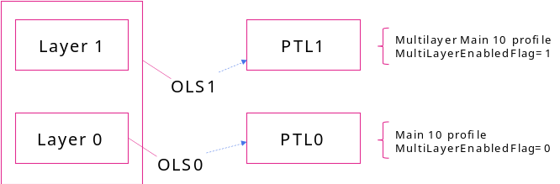
Figure 2. Proposal 1 of new conformance test
The command line arguments for this conformance test using fixed software is as follows:
EncoderApp.exe -c encoder_randomaccess_vtm.cfg -c multi-layer/two_layers_multi_profiles.cfg -c per-sequence/BQSquare.cfg -l0 --Profile=main_10 -l1 --Profile=multilayer_main_10
-l1 --MultiLayerEnabledFlag=1 -q 37 -f 9 -b proposal1.bin
Additional configuration file “two_layers_multi_profiles.cfg” is enclosed in the contribution.

The same PTL applying to multiple independent layers
The second proposal of the conformance test is to signal one profile applying to different OLSs. Specifically, both layer0 and layer1 are coded as independent layers and Main 10 profile applies to both OLSs (each OLS includes one layer).
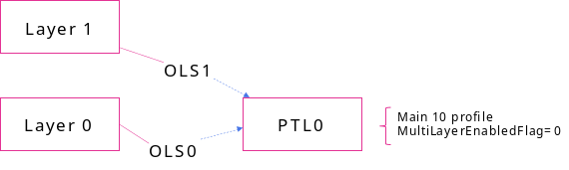
Figure 3. Proposal 2 of new conformance test
The command line arguments for this conformance test using fixed software is as follows:
EncoderApp.exe -c encoder_randomaccess_vtm.cfg -c multi-layer/two_layers_independent.cfg
--Profile=main_10 -c per-sequence/BQSquare.cfg -q 37 -f 9 -b proposal2.bin
Additional configuration file “two_layers_independent.cfg” is also enclosed in the contribution.

Conclusion
This contribution reports issues on the limitation of VTM implementation, where some multilayer use cases are not supported. A patch for software fix is provided in the contribution. Additionally, two new conformance tests related to the software fix are proposed.

Patent rights declaration(s)
NHK may have current or pending patent rights relating to the technology described in this contribution and, conditioned on reciprocity, is prepared to grant licenses under reasonable and non-discriminatory terms as necessary for implementation of the resulting ITU-T Recommendation | ISO/IEC International Standard (per box 2 of the ITU-T/ITU-R/ISO/IEC patent statement and licensing declaration form).

